UNITED STATES
SECURITIES AND EXCHANGE COMMISSION
WASHINGTON, D.C. 20549
________________________________________
FORM 8-K
________________________________________
CURRENT REPORT
Pursuant to Section 13 or 15(d) of the Securities Exchange Act of 1934
Date of Report (Date of earliest event reported): September 15, 2026
________________________________________
Connect Biopharma Holdings Limited
(Exact name of Registrant as Specified in Its Charter)
________________________________________
Cayman Islands |  |  | 001-40212 |  |  | Not Applicable
(State or Other Jurisdiction  of Incorporation) |  |  | (Commission File Number) |  |  | (IRS Employer  Identification No.)
 |  |  | 3580 Carmel Mountain Road, Suite 200
 |  |  | San Diego, California |  |  | 92130
 |  |  | (Address of Principal Executive Offices) |  |  | (Zip Code)
Registrant’s Telephone Number, Including Area Code: (877) 245-2787
________________________________________
Check the appropriate box below if the Form 8-K filing is intended to simultaneously satisfy the filing obligation of the registrant under any of the following provisions:
o |  |  | Written communications pursuant to Rule 425 under the Securities Act (17 CFR 230.425)
o |  |  | Soliciting material pursuant to Rule 14a-12 under the Exchange Act (17 CFR 240.14a-12)
o |  |  | Pre-commencement communications pursuant to Rule 14d-2(b) under the Exchange Act (17 CFR 240.14d-2(b))
o |  |  | Pre-commencement communications pursuant to Rule 13e-4(c) under the Exchange Act (17 CFR 240.13e-4(c))
Securities registered pursuant to Section 12(b) of the Act:
Title of each class |  |  |  |  |  | Trading  Symbol(s) |  |  |  |  |  | Name of each exchange on which registered
Ordinary Shares, par value $0.000174 per Share |  |  |  |  |  | CNTB |  |  |  |  |  | The Nasdaq Global Market
Indicate by check mark whether the registrant is an emerging growth company as defined in Rule 405 of the Securities Act of 1933 (§ 230.405 of this chapter) or Rule 12b-2 of the Securities Exchange Act of 1934 (§ 240.12b-2 of this chapter).
Emerging growth company ☒
If an emerging growth company, indicate by check mark if the registrant has elected not to use the extended transition period for complying with any new or revised financial accounting standards provided pursuant to Section 13(a) of the Exchange Act. o

Item 7.01 Regulation FD Disclosure.
Press Release.
On September 15, 2026, Connect Biopharma Holdings Limited (the “Company”) issued a press release announcing topline results from its global phase 2 study evaluating rademikibart, the Company’s next-generation, potentially best-in-class anti-interleukin-4-receptor alpha antibody as an add-on treatment for acute exacerbations in adult and adolescent participants with asthma and type 2 inflammation (the “Asthma Study”). A copy of the press release is attached as Exhibit 99.1 and is incorporated herein by reference.
Corporate Presentation.
A copy of presentation materials related to the Asthma Study, all or a part of which may be used by the Company in investor or scientific presentations from time to time, is furnished herewith as Exhibit 99.2 (the “Corporate Presentation”). The Company does not undertake any obligation to update the Corporate Presentation.
The information in this Item 7.01, including in Exhibit 99.1 and Exhibit 99.2, shall not be deemed “filed” for purposes of Section 18 of the Securities Exchange Act of 1934, as amended (the “Exchange Act”), or otherwise subject to the liabilities of that section, nor shall it be deemed incorporated by reference in any filing under the Securities Act of 1933, as amended, or the Exchange Act, whether made before or after the date hereof, except as expressly set forth by specific reference in such filing.

Item 8.01 Other Events.
On September 15, 2026, the Company announced topline results for the Asthma Study.
The Asthma Study is a randomized, double-blind, placebo-controlled study that evaluated the safety and efficacy of rademikibart as an adjunct to standard of care for acute exacerbations in adult and adolescent participants with asthma and type 2 inflammation. The study enrolled 160 patients who were randomized 1:1 to receive either a 600mg dose of rademikibart (n=79) or placebo (n=81), administered subcutaneously in addition to standard of care. The primary endpoint was treatment failure, defined as death due to any cause, (re)admission to a hospital for asthma, emergency department (re)visit or unscheduled medical visit for worsening of asthma symptoms, or the necessity to intensify pharmacologic treatment within 28 days after randomization. The key secondary endpoint was absolute change from baseline in post-bronchodilator forced expiratory volume in one second (“FEV1”) at Week 1, which is also the proposed primary endpoint for Phase 3.
Key topline results include:
•Rademikibart demonstrated a statistically significant increase from baseline in post-bronchodilator FEV1 on Day 7 of 250 mL compared to 120 mL with placebo (130mL greater improvement compared to placebo; p=0.023).
•Rademikibart reduced the treatment failure rate by approximately 66% over 28 days compared to placebo (p=0.153).
•The endpoint missed statistical significance due to an overall lower treatment failure rate than projected.
•50% reduction in emergency department visits or unscheduled medical visits for worsening asthma symptoms compared to placebo.
•Rademikibart was well tolerated and no new safety signals were observed through the end of the study. The safety profile was comparable to placebo, with a low incidence of adverse events (“AEs”) in both arms, no individual AE occurring in more than two participants, no AEs leading to study discontinuation in either arm, and one serious adverse event (“SAE”) reported in the rademikibart arm compared to three SAEs in the placebo arm.
The Company expects to report topline data from the ongoing Phase 2 Seabreeze STAT chronic obstructive pulmonary disease (“COPD”) study (CBP-201-207) of rademikibart for the treatment of acute exacerbations in COPD patients with type 2 inflammation later this month and plans to move quickly to meet with the U.S. Food and Drug Administration (“FDA”) to gain alignment on a Phase 3 program.

Item 9.01 Financial Statements and Exhibits.
(d) Exhibits
Exhibit No. |  |  |  |  |  | Description
99.1 |  |  |  |  |  | Press Release of the Company, dated September 15, 2026
99.2 |  |  |  |  |  | Corporate Presentation, dated September 15, 2026
104 |  |  |  |  |  | Cover Page Interactive Data File (embedded within the Inline XBRL document)

Forward-Looking Statements
The Company cautions you that statements contained in this Current Report on Form 8-K, including in the exhibits furnished herewith, regarding matters that are not historical facts are forward-looking statements. The forward-looking statements are based on our current beliefs and expectations and include, but are not limited to, statements regarding: our future financial and operating results and related expectations, business strategy and plans, prospective products (as well as their potential to achieve a differentiated, competitive, or favorable benefit or profile or trend, including on safety, tolerability, improvement, maintenance, clinical response, dosing, efficacy and/or convenience), statements regarding the timing or results of any interim analysis or interim, topline or preliminary data and whether such analysis or data is indicative of safety, efficacy, final trial results or likelihood of regulatory approval for our product candidates, planned or expected meetings with the FDA or any other regulatory authorities, planned or expected product approval applications or approvals, anticipated milestones and milestone payments, expected data readouts and enrollments and the timing thereof, research and development plans and costs including expectations for future clinical studies, potential future partnerships, expectations about existing partnerships, timing and likelihood of success, objectives of management for future operations, future results of anticipated product development efforts, adequacy of existing cash and potential partnership funding to fund operations and capital expenditure requirements, anticipated patient populations, market opportunities and potential pricing strategies for our prospective products, if approved, our plans for rademikibart, including potential indications, as well as statements regarding industry trends. The inclusion of forward-looking statements should not be regarded as a representation by the Company that any of these plans will be achieved. Actual results may differ from those set forth in this Current Report on Form 8-K due to the risks and uncertainties inherent in the Company’s business and beyond its control, including, without limitation: the ability of our clinical trials to demonstrate safety and efficacy of our product candidates and other positive results; whether we will need expanded or additional trials in order to obtain regulatory approval for our product candidates; the timing and outcome of any meetings with the FDA or other regulatory authorities regarding further development of our product candidates, including with respect to a potential Phase 3 program for rademikibart; our ability to obtain and maintain regulatory approval of our product candidates; existing regulations and regulatory developments in the U.S., the People’s Republic of China, Europe and other jurisdictions; our plans and ability to obtain, maintain, protect and enforce our intellectual property rights and our proprietary technologies, including extensions of existing patent terms where available; our continued reliance on third parties to conduct additional clinical trials of our product candidates, and for the manufacture of our product candidates for preclinical studies and clinical trials; the degree of market acceptance of our product candidates, if approved, by physicians, patients, healthcare payors and others in the medical community; the impact on our business of adverse global macroeconomic and geopolitical conditions, including high interest rates, the inflationary environment, recessionary fears, foreign exchange rate volatility, instability in financial institutions, government shutdowns, changes in monetary policy, changes in trade policies, including tariffs and other trade restrictions or the threat of such actions, and rising geopolitical instability, including the conflicts in the Middle East and the related volatility in the price of oil and other commodity prices; and other risks described in our Annual Report on Form 10-K for the fiscal year ended December 31, 2025, and in any subsequent filings with the SEC. You are cautioned not to place undue reliance on these forward-looking statements, which speak only as of the date hereof, and we undertake no obligation to update such statements to reflect events that occur or circumstances that exist after the date hereof. All forward-looking statements are qualified in their entirety by this cautionary statement, which is made under the safe harbor provisions of the Private Securities Litigation Reform Act of 1995.

SIGNATURES
Pursuant to the requirements of the Securities Exchange Act of 1934, the registrant has duly caused this report to be signed on its behalf by the undersigned hereunto duly authorized.
 |  |  |  |  |  |  |  |  | CONNECT BIOPHARMA HOLDINGS LIMITED
Date: |  |  | September 15, 2026 |  |  | By: |  |  | /s/ David Szekeres
 |  |  |  |  |  | Name: |  |  | David Szekeres
 |  |  |  |  |  | Title: |  |  | President

Exhibit 99.1

Connect Biopharma Announces Positive Preliminary Topline Data from its Global Phase 2 Study of Rademikibart as an Add-on Treatment for Acute Exacerbations in Adult and Adolescent Participants with Asthma and Type 2 Inflammation

– Rademikibart meaningfully reduced the rate of treatment failure at 28 days by 66% compared to placebo –
–Rademikibart produced a rapid, statistically significant improvement in lung function at Day 7 compared to placebo –
– Rademikibart was well tolerated in asthma patients experiencing an acute exacerbation with a low incidence of adverse events–
– Data from Seabreeze STAT COPD study of rademikibart will be available later this month after which Connect plans to engage with the U.S. Food and Drug Administration (FDA) to gain alignment on a Phase 3 program –
– Company to host a conference call to discuss the data today, September 15 at 8:00 a.m. ET –
SAN DIEGO, SEPTEMBER 15, 2026 (GLOBE NEWSWIRE) -- Connect Biopharma Holdings Limited (Nasdaq: CNTB) (Connect Biopharma, Connect or the Company), a clinical-stage biopharmaceutical company focused on transforming care for the treatment of inflammatory diseases, today announced topline results from its global phase 2 study evaluating rademikibart, the Company’s next-generation, potentially best-in-class anti-interleukin-4-receptor alpha (IL-4Rα) antibody as an add-on treatment for acute exacerbations in adult and adolescent participants with asthma and type 2 inflammation.

“Topline data from our Seabreeze STAT asthma trial for rademikibart supports its potential to meaningfully improve outcomes for patients in the critical period after an exacerbation,” said Barry Quart, Pharm.D., CEO and Director of Connect Biopharma. “Today’s data highlight the statistically significant rapid improvements in FEV1 within one week post treatment as well as a 66% reduction in treatment failures at 28 days, although that endpoint did not reach statistical significance. The overall results of this study provide a clear roadmap for design of a Phase 3 program. Taken together with updated market research showing approximately 1.6M ED visits in 2025 for acute asthma exacerbation by high-T2 patients, we believe these results support the potential of rademikibart to deliver significant patient impact and reduce the health economic burden for patients and hospitals. Looking ahead, we intend to report topline data from our Phase 2 Seabreeze STAT chronic obstructive pulmonary disease (COPD) trial later this month. Following which we plan to engage with the FDA regarding a Phase 3 registrational development program for rademikibart as add-on treatment for acute exacerbations of asthma and COPD.”

“Patients who experience acute exacerbations remain at an elevated risk for subsequent exacerbations and worsening of symptoms despite current standard-of-care,” said Michael Wechsler, MD, Director of the Cohen Family Asthma Institute and Professor of Medicine at National Jewish Health in Denver, Colorado. “66% reduction in treatment failure is an exceptional outcome and is particularly impressive and shows a meaningful improvement over standard-of-care therapy alone. The ability to deliver this magnitude of benefit while also significantly improving lung function underscores the potential of rademikibart to improve outcomes and establish a new treatment paradigm for managing acute exacerbations in the hospital setting.”

The Phase 2 Seabreeze STAT Asthma study (CBP-201-206) is a randomized, double-blind, placebo-controlled study that evaluated the safety and efficacy of rademikibart as an adjunct to standard of care for acute exacerbations in adult and adolescent participants with asthma and type 2 inflammation. The study enrolled 160 patients who were randomized 1:1 to receive either a 600mg dose of rademikibart (n=79) or placebo (n=81), administered subcutaneously in addition to standard of care. The primary endpoint was treatment failure, defined as death due to any cause, (re)admission to a hospital for asthma, emergency department (ED) (re)visit or unscheduled medical visit for worsening of asthma symptoms, or the necessity to intensify pharmacologic treatment within 28 days after randomization. The key secondary endpoint was absolute change from baseline in post-bronchodilator (post-BD) forced expiratory volume in one second (FEV1) at Week 1, which is also the proposed primary endpoint for Phase 3.
Key topline results include:
•Rademikibart demonstrated a statistically significant increase from baseline in post-bronchodilator FEV1 on Day 7 of 250 mL compared to 120 mL with placebo (130mL greater improvement compared to placebo; p=0.023)
•Rademikibart reduced the treatment failure rate by approximately 66% over 28 days compared to placebo (p=0.153).
oThe endpoint missed statistical significance due to an overall lower treatment failure rate than projected
•50% reduction in emergency department visits or unscheduled medical visits for worsening asthma symptoms compared to placebo
•Rademikibart was well tolerated and no new safety signals were observed through the end of the study. The safety profile was comparable to placebo, with a low incidence of adverse events (AEs) in both arms, no individual AE occurring in more than 2 participants, no AEs leading to study discontinuation in either arm, and one serious adverse event (SAE) reported in the rademikibart arm compared to 3 SAEs in the placebo arm.

Connect expects to report topline data from the ongoing Phase 2 Seabreeze STAT COPD study (CBP-201-207) of rademikibart for the treatment of acute exacerbations in COPD patients with type 2 inflammation later this month and plans to move quickly to meet with the FDA to gain alignment on a Phase 3 program.

Company-Hosted Conference Call and Webcast

Connect will host a conference call and webcast today, September 15, 2026, at 8:00 a.m. ET. To access the conference call, please pre-register through here to receive dial-in information and a personal PIN to access the live call. Participants may access the live webcast here or from the Investors section of the Connect website at investors.connectbiopharma.com. An archive of the webcast and presentation will be available for approximately 90 days after the event.

About the Seabreeze STAT Asthma Study

Seabreeze STAT Asthma is a Phase 2, randomized, double-blind, placebo-controlled study evaluating the safety and efficacy of rademikibart as an adjunct to standard of care for acute exacerbations in adult and adolescent participants with asthma and type 2 inflammation. The study has enrolled 160 participants globally with an eosinophil count of ≥300 cells/μL who have

experienced an acute asthma exacerbation. Participants received either a single dose of rademikibart or placebo, administered subcutaneously. The primary endpoint is treatment failure rate over 28 days following an acute exacerbation. The key secondary endpoint is post-bronchodilator (post-BD) forced expiratory volume in one second (FEV1) at Week 1. Other secondary endpoints include rate and time to new asthma exacerbations, change-from-baseline in asthma symptom score and nocturnal awakenings, post-BD FEV1 at other timepoints, and incidence of adverse events for 8 weeks after dosing. For more information, please visit clinicaltrials.gov (identifier NCT06940141).

About Rademikibart

Rademikibart is a fully human monoclonal antibody targeting interleukin-4 receptor alpha (IL-4Rα), a common subunit of interleukin-4 receptor (IL-4) and interleukin-13 receptor (IL-13). We believe that by binding with IL-4Rα, rademikibart can block the functions of IL-4 and IL-13 effectively, thereby blocking the T helper 2 (Th2) inflammatory pathway to achieving the goal of treating Th2 related inflammatory diseases such as atopic dermatitis, asthma and COPD.

About Connect Biopharma

Connect Biopharma is a clinical-stage biopharmaceutical company dedicated to transforming care for asthma and COPD. Headquartered in San Diego, California, the Company is advancing rademikibart, a next-generation, potentially best-in-class antibody designed to target IL-4Rα. The Company is currently conducting global clinical studies of rademikibart for the treatment of acute exacerbations of asthma and COPD, areas with significant unmet need. Connect has granted an exclusive license to Simcere Pharmaceutical Co., Ltd., for rademikibart in Greater China. Under the exclusive license and collaboration agreement, Connect is eligible to receive remaining milestone payments up to an aggregate amount of approximately $99 million upon the achievement of certain development, regulatory and commercial milestones. Connect is also eligible to receive royalties at tiered percentage rates up to low double-digit percentages on net sales in Greater China.

For more information visit www.connectbiopharma.com.

Forward-Looking Statements

This press release contains “forward-looking statements” within the meaning of the Private Securities Litigation Reform Act of 1995, as amended. Forward-looking statements are statements that are not of historical fact and include, without limitation, statements regarding future events, our future financial and operating results and related expectations, business strategy and plans, prospective products (as well as their potential to achieve a differentiated, competitive, or favorable benefit or profile or trend, including on safety, tolerability, improvement, maintenance, clinical response, dosing, efficacy and/or convenience), statements regarding the timing or results of any interim analysis or interim, topline or preliminary data and whether such analysis or data is indicative of safety, efficacy, final trial results or likelihood of regulatory approval for our product candidates, planned or expected meetings with the FDA or any other regulatory authorities, planned or expected product approval applications or approvals, anticipated milestones and milestone payments, expected data readouts and enrollments and the timing thereof, research and development plans and costs, potential future partnerships, expectations about existing partnerships, timing and likelihood of success, objectives of management for future operations, future results of anticipated product development efforts,

adequacy of existing cash and potential partnership funding to fund operations and capital expenditure requirements, anticipated patient populations, market opportunities and potential pricing strategies for our prospective products, if approved, our plans for rademikibart, including potential indications, as well as statements regarding industry trends. These statements are based on management’s current expectations of future events only as of the date of this press release and are inherently subject to a number of risks, uncertainties and assumptions, some of which cannot be predicted or quantified and some of which are beyond our control, including, among other things: the ability of our clinical trials to demonstrate safety and efficacy of our product candidates and other positive results; whether we will need expanded or additional trials in order to obtain regulatory approval for our product candidates; the timing and outcome of any meetings with the FDA or other regulatory authorities regarding further development of our product candidates, including with respect to a potential Phase 3 program for rademikibart; our ability to obtain and maintain regulatory approval of our product candidates; existing regulations and regulatory developments in the U.S., the People’s Republic of China, Europe and other jurisdictions; our plans and ability to obtain, maintain, protect and enforce our intellectual property rights and our proprietary technologies, including extensions of existing patent terms where available; our continued reliance on third parties to conduct additional clinical trials of our product candidates, and for the manufacture of our product candidates for preclinical studies and clinical trials; the degree of market acceptance of our product candidates, if approved, by physicians, patients, healthcare payors and others in the medical community; the impact on our business of adverse global macroeconomic and geopolitical conditions, including high interest rates, the inflationary environment, recessionary fears, foreign exchange rate volatility, instability in financial institutions, government shutdowns, changes in monetary policy, changes in trade policies, including tariffs and other trade restrictions or the threat of such actions, and rising geopolitical instability, including the conflicts in the Middle East and the related volatility in the price of oil and other commodity prices; as well as the risks and uncertainties described in Part I, “Item 1A. Risk Factors” of our Annual Report on Form 10-K for the year ended December 31, 2025, our subsequent Quarterly Reports on Form 10-Q and our other filings with the SEC .

Words such as “aim,” “anticipate,” “believe,” “commitments,” “continue,” “could,” “design,” “estimate,” “expect,” “feel,” “goal,” “intend,” “may,” “might,” “objective,” “optimistic,” “plan,” “potential,” “predict,” “promising,” “seek,” “should,” “target,” “will,” “would,” and similar expressions are intended to identify forward-looking statements, though not all forward-looking statements necessarily contain these identifying words. The inclusion of forward-looking statements should not be regarded as a representation by Connect Biopharma that any of its expectations, projections or plans will be achieved. Actual results or outcomes, or the timing of such results or outcomes, may differ materially from those expressed or implied in our forward-looking statements due to the risks and uncertainties described above. These forward-looking statements should not be taken as forecasts or promises nor should they be taken as implying any indication, assurance or guarantee that the assumptions on which such forward-looking statements have been made are correct or exhaustive or, in the case of the assumptions, fully stated herein. Drug development and commercialization involve a high degree of risk, and only a small number of research and development programs result in commercialization of a product. Results in early-stage clinical trials may not be indicative of full results or results from later stage or larger scale clinical trials and do not ensure regulatory approval. You are cautioned not to place undue reliance on the scientific data presented or these forward-looking statements, which speak only as of the date hereof. Except as required by law, Connect Biopharma undertakes no obligation to publicly update any forward-looking statements, whether because of new information, future events or otherwise.

This press release discusses our product candidate, rademikibart, which is under clinical investigation and has not yet been approved for marketing by the FDA, the NMPA, or by any other regulatory agency. No representation is made as to the safety or effectiveness of rademikibart for the uses for which it is being studied. The trademarks included herein are the property of the owners thereof and are used for reference purposes only.

Investor Relations Contact:

Alex Lobo
Precision AQ
Alex.lobo@precisionaq.com
(212) 698-8802

Media Contact:

Ignacio Guerrero-Ros, Ph.D., or David Schull
Russo Partners, LLC
Ignacio.guerrero-ros@russopartnersllc.com
David.schull@russopartnersllc.com
(858) 717-2310 or (646) 942-5604
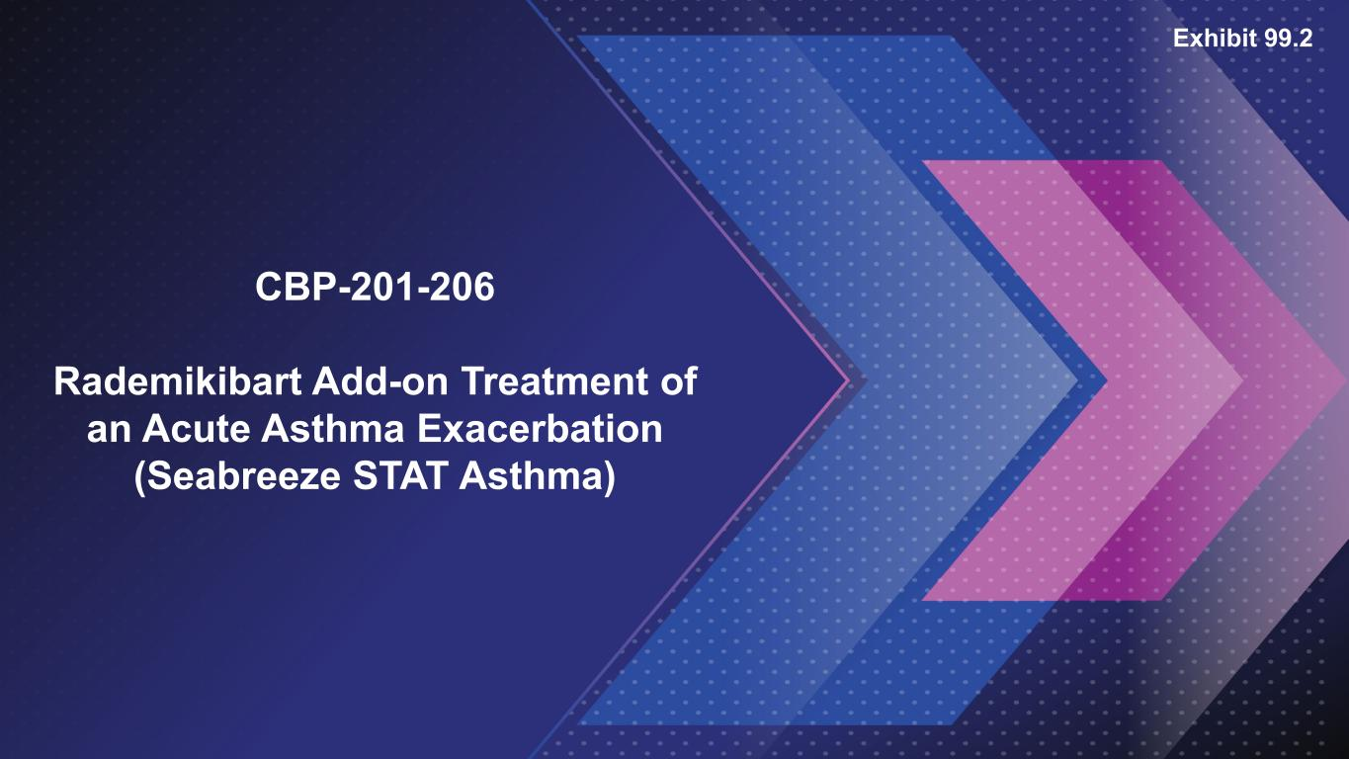

CBP-201-206 Rademikibart Add-on Treatment of an Acute Asthma Exacerbation (Seabreeze STAT Asthma) Exhibit 99.2

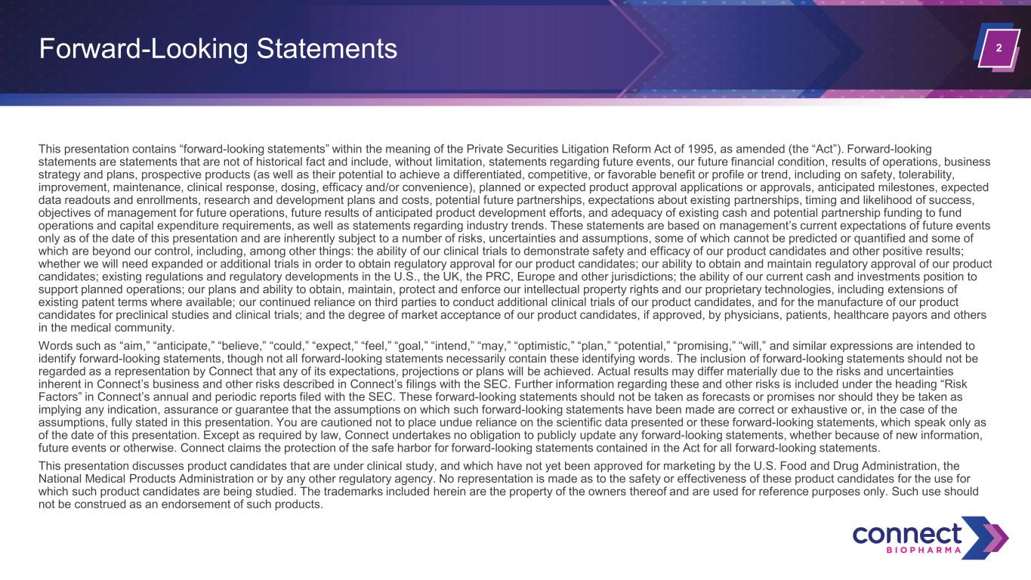
2 This presentation contains “forward-looking statements” within the meaning of the Private Securities Litigation Reform Act of 1995, as amended (the “Act”). Forward-looking statements are statements that are not of historical fact and include, without limitation, statements regarding future events, our future financial condition, results of operations, business strategy and plans, prospective products (as well as their potential to achieve a differentiated, competitive, or favorable benefit or profile or trend, including on safety, tolerability, improvement, maintenance, clinical response, dosing, efficacy and/or convenience), planned or expected product approval applications or approvals, anticipated milestones, expected data readouts and enrollments, research and development plans and costs, potential future partnerships, expectations about existing partnerships, timing and likelihood of success, objectives of management for future operations, future results of anticipated product development efforts, and adequacy of existing cash and potential partnership funding to fund operations and capital expenditure requirements, as well as statements regarding industry trends. These statements are based on management’s current expectations of future events only as of the date of this presentation and are inherently subject to a number of risks, uncertainties and assumptions, some of which cannot be predicted or quantified and some of which are beyond our control, including, among other things: the ability of our clinical trials to demonstrate safety and efficacy of our product candidates and other positive results; whether we will need expanded or additional trials in order to obtain regulatory approval for our product candidates; our ability to obtain and maintain regulatory approval of our product candidates; existing regulations and regulatory developments in the U.S., the UK, the PRC, Europe and other jurisdictions; the ability of our current cash and investments position to support planned operations; our plans and ability to obtain, maintain, protect and enforce our intellectual property rights and our proprietary technologies, including extensions of existing patent terms where available; our continued reliance on third parties to conduct additional clinical trials of our product candidates, and for the manufacture of our product candidates for preclinical studies and clinical trials; and the degree of market acceptance of our product candidates, if approved, by physicians, patients, healthcare payors and others in the medical community. Words such as “aim,” “anticipate,” “believe,” “could,” “expect,” “feel,” “goal,” “intend,” “may,” “optimistic,” “plan,” “potential,” “promising,” “will,” and similar expressions are intended to identify forward-looking statements, though not all forward-looking statements necessarily contain these identifying words. The inclusion of forward-looking statements should not be regarded as a representation by Connect that any of its expectations, projections or plans will be achieved. Actual results may differ materially due to the risks and uncertainties inherent in Connect’s business and other risks described in Connect’s filings with the SEC. Further information regarding these and other risks is included under the heading “Risk Factors” in Connect’s annual and periodic reports filed with the SEC. These forward-looking statements should not be taken as forecasts or promises nor should they be taken as implying any indication, assurance or guarantee that the assumptions on which such forward-looking statements have been made are correct or exhaustive or, in the case of the assumptions, fully stated in this presentation. You are cautioned not to place undue reliance on the scientific data presented or these forward-looking statements, which speak only as of the date of this presentation. Except as required by law, Connect undertakes no obligation to publicly update any forward-looking statements, whether because of new information, future events or otherwise. Connect claims the protection of the safe harbor for forward-looking statements contained in the Act for all forward-looking statements. This presentation discusses product candidates that are under clinical study, and which have not yet been approved for marketing by the U.S. Food and Drug Administration, the National Medical Products Administration or by any other regulatory agency. No representation is made as to the safety or effectiveness of these product candidates for the use for which such product candidates are being studied. The trademarks included herein are the property of the owners thereof and are used for reference purposes only. Such use should not be construed as an endorsement of such products. Forward-Looking Statements

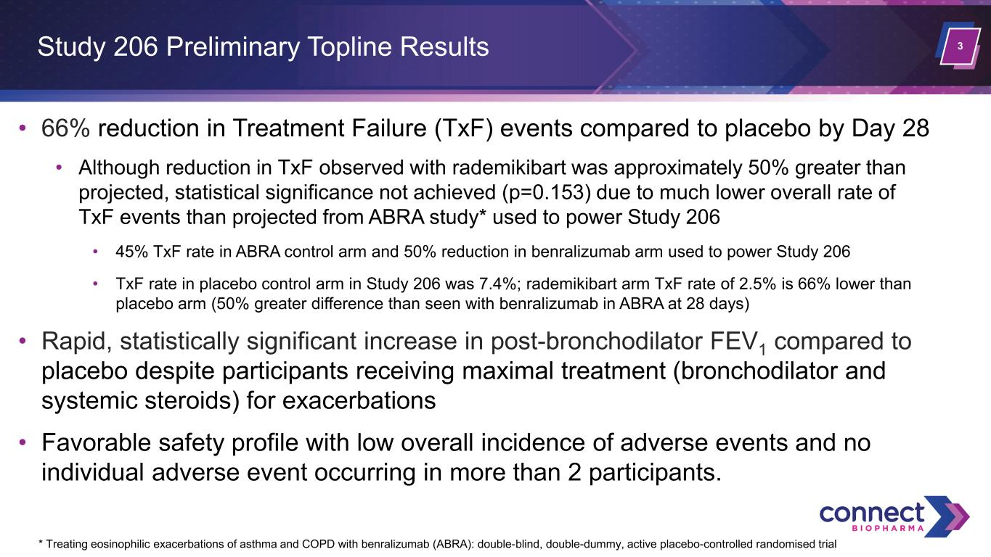
3 • 66% reduction in Treatment Failure (TxF) events compared to placebo by Day 28 • Although reduction in TxF observed with rademikibart was approximately 50% greater than projected, statistical significance not achieved (p=0.153) due to much lower overall rate of TxF events than projected from ABRA study* used to power Study 206 • 45% TxF rate in ABRA control arm and 50% reduction in benralizumab arm used to power Study 206 • TxF rate in placebo control arm in Study 206 was 7.4%; rademikibart arm TxF rate of 2.5% is 66% lower than placebo arm (50% greater difference than seen with benralizumab in ABRA at 28 days) • Rapid, statistically significant increase in post-bronchodilator FEV1 compared to placebo despite participants receiving maximal treatment (bronchodilator and systemic steroids) for exacerbations • Favorable safety profile with low overall incidence of adverse events and no individual adverse event occurring in more than 2 participants. Study 206 Preliminary Topline Results * Treating eosinophilic exacerbations of asthma and COPD with benralizumab (ABRA): double-blind, double-dummy, active placebo-controlled randomised trial

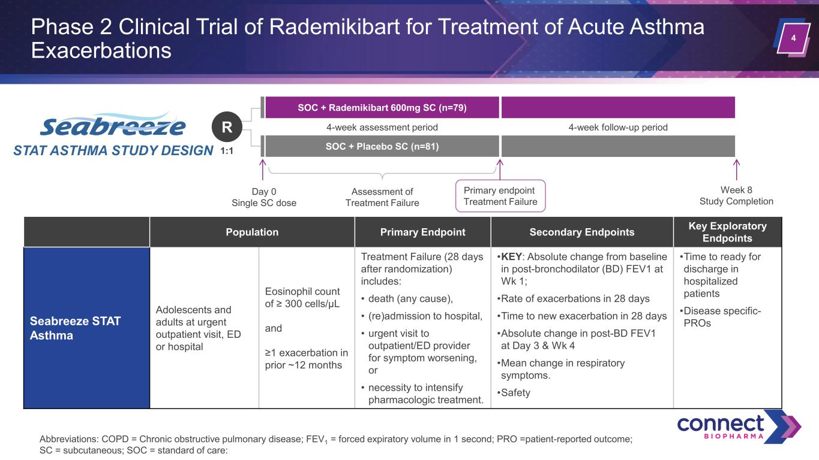
4 Phase 2 Clinical Trial of Rademikibart for Treatment of Acute Asthma Exacerbations Abbreviations: COPD = Chronic obstructive pulmonary disease; FEV1 = forced expiratory volume in 1 second; PRO =patient-reported outcome; SC = subcutaneous; SOC = standard of care: SOC + Placebo SC (n=81) Assessment of Treatment Failure Day 0 Single SC dose SOC + Rademikibart 600mg SC (n=79) Primary endpoint Treatment Failure 4-week follow-up period Week 8 Study Completion 4-week assessment period STAT ASTHMA STUDY DESIGN 1:1 R Population Primary Endpoint Secondary Endpoints Key Exploratory Endpoints Seabreeze STAT Asthma Adolescents and adults at urgent outpatient visit, ED or hospital Eosinophil count of ≥ 300 cells/µL and ≥1 exacerbation in prior ~12 months Treatment Failure (28 days after randomization) includes: • death (any cause), • (re)admission to hospital, • urgent visit to outpatient/ED provider for symptom worsening, or • necessity to intensify pharmacologic treatment. •KEY: Absolute change from baseline in post-bronchodilator (BD) FEV1 at Wk 1; •Rate of exacerbations in 28 days •Time to new exacerbation in 28 days •Absolute change in post-BD FEV1 at Day 3 & Wk 4 •Mean change in respiratory symptoms. •Safety •Time to ready for discharge in hospitalized patients •Disease specific- PROs

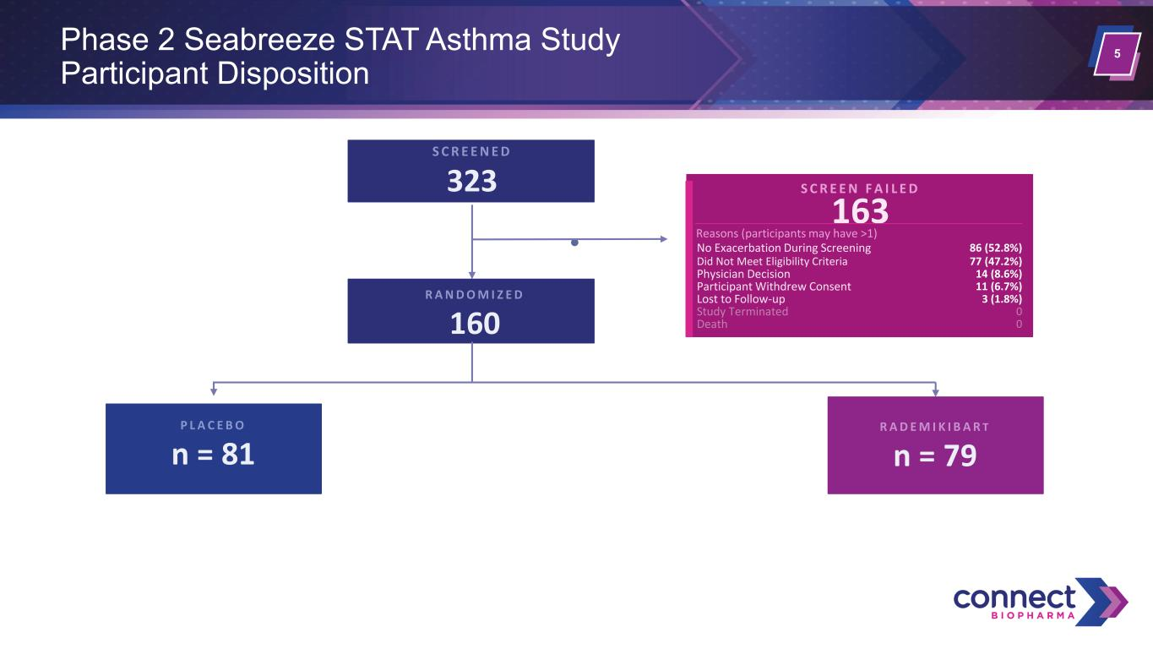
5Phase 2 Seabreeze STAT Asthma Study Participant Disposition S C R E E N E D 323 S C R E E N F A I L E D 163 Reasons (participants may have >1) Did Not Meet Eligibility Criteria 77 (47.2%) No Exacerbation During Screening 86 (52.8%) Physician Decision 14 (8.6%) Participant Withdrew Consent 11 (6.7%) Lost to Follow-up 3 (1.8%) Study Terminated 0 Death 0 R A N D O M I Z E D 160 P L A C E B O n = 81 R A D E M I K I B A R T n = 79

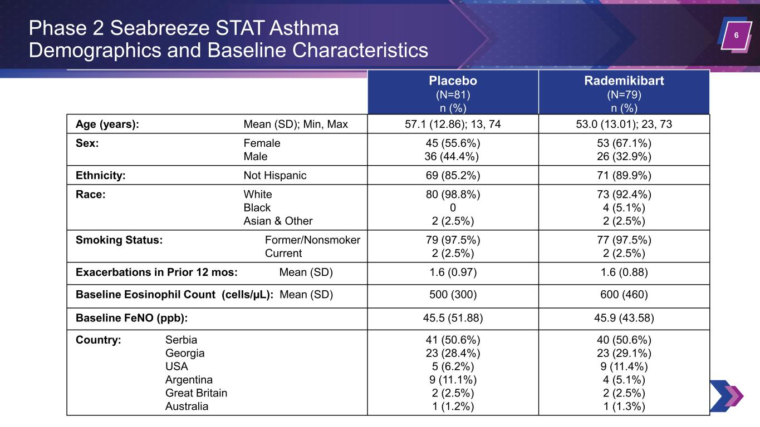
6 Placebo (N=81) n (%) Rademikibart (N=79) n (%) Age (years): Mean (SD); Min, Max 57.1 (12.86); 13, 74 53.0 (13.01); 23, 73 Sex: Female Male 45 (55.6%) 36 (44.4%) 53 (67.1%) 26 (32.9%) Ethnicity: Not Hispanic 69 (85.2%) 71 (89.9%) Race: White Black Asian & Other 80 (98.8%) 0 2 (2.5%) 73 (92.4%) 4 (5.1%) 2 (2.5%) Smoking Status: Former/Nonsmoker Current 79 (97.5%) 2 (2.5%) 77 (97.5%) 2 (2.5%) Exacerbations in Prior 12 mos: Mean (SD) 1.6 (0.97) 1.6 (0.88) Baseline Eosinophil Count (cells/µL): Mean (SD) 500 (300) 600 (460) Baseline FeNO (ppb): 45.5 (51.88) 45.9 (43.58) Country: Serbia Georgia USA Argentina Great Britain Australia 41 (50.6%) 23 (28.4%) 5 (6.2%) 9 (11.1%) 2 (2.5%) 1 (1.2%) 40 (50.6%) 23 (29.1%) 9 (11.4%) 4 (5.1%) 2 (2.5%) 1 (1.3%) Phase 2 Seabreeze STAT Asthma Demographics and Baseline Characteristics

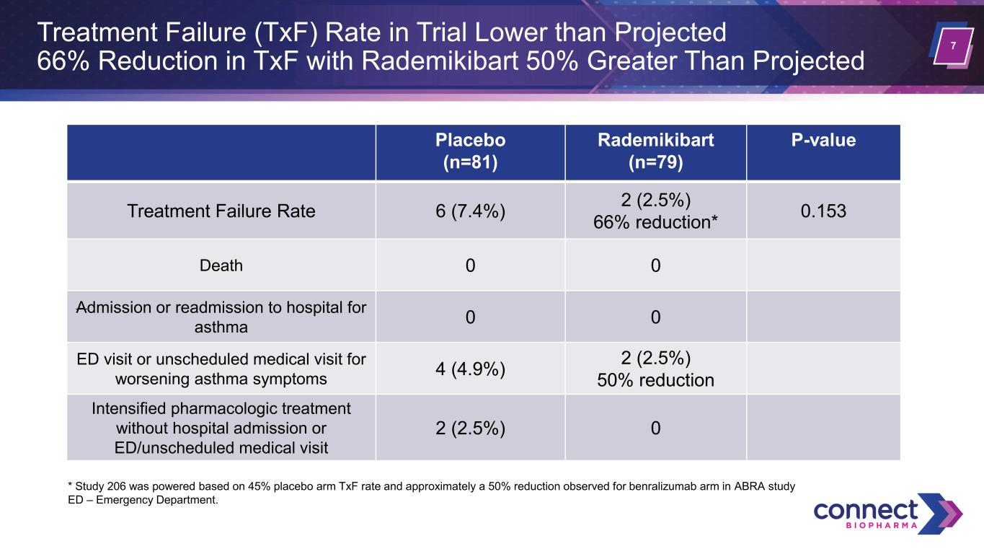
7 Treatment Failure (TxF) Rate in Trial Lower than Projected 66% Reduction in TxF with Rademikibart 50% Greater Than Projected Placebo (n=81) Rademikibart (n=79) P-value Treatment Failure Rate 6 (7.4%) 2 (2.5%) 66% reduction* 0.153 Death 0 0 Admission or readmission to hospital for asthma 0 0 ED visit or unscheduled medical visit for worsening asthma symptoms 4 (4.9%) 2 (2.5%) 50% reduction Intensified pharmacologic treatment without hospital admission or ED/unscheduled medical visit 2 (2.5%) 0 * Study 206 was powered based on 45% placebo arm TxF rate and approximately a 50% reduction observed for benralizumab arm in ABRA study ED – Emergency Department.

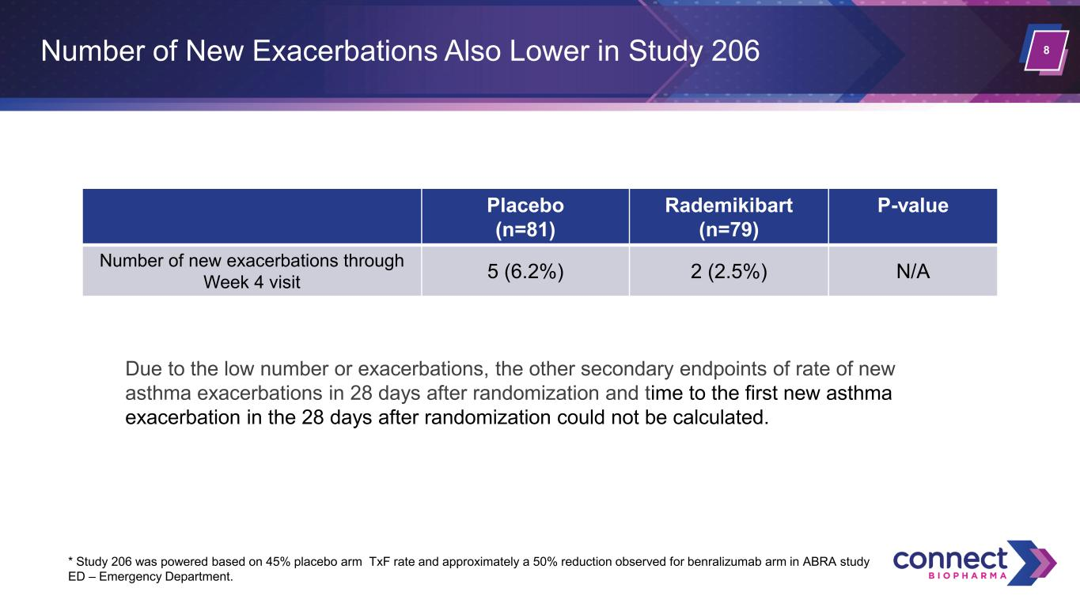
8Number of New Exacerbations Also Lower in Study 206 Placebo (n=81) Rademikibart (n=79) P-value Number of new exacerbations through Week 4 visit 5 (6.2%) 2 (2.5%) N/A * Study 206 was powered based on 45% placebo arm TxF rate and approximately a 50% reduction observed for benralizumab arm in ABRA study ED – Emergency Department. Due to the low number or exacerbations, the other secondary endpoints of rate of new asthma exacerbations in 28 days after randomization and time to the first new asthma exacerbation in the 28 days after randomization could not be calculated.

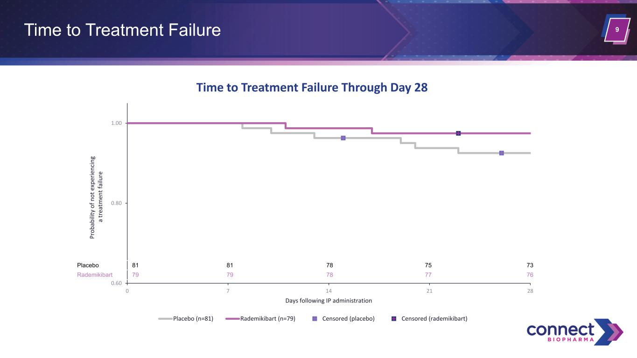
9Time to Treatment Failure 0.60 0.80 1.00 0 7 14 21 28 Pr ob ab ili ty o f n ot e xp er ie nc in g a tr ea tm en t f ai lu re Days following IP administration Placebo (n=81) Rademikibart (n=79) Censored (placebo) Censored (rademikibart) Placebo 81 81 78 75 73 Rademikibart 79 79 78 77 76 Time to Treatment Failure Through Day 28

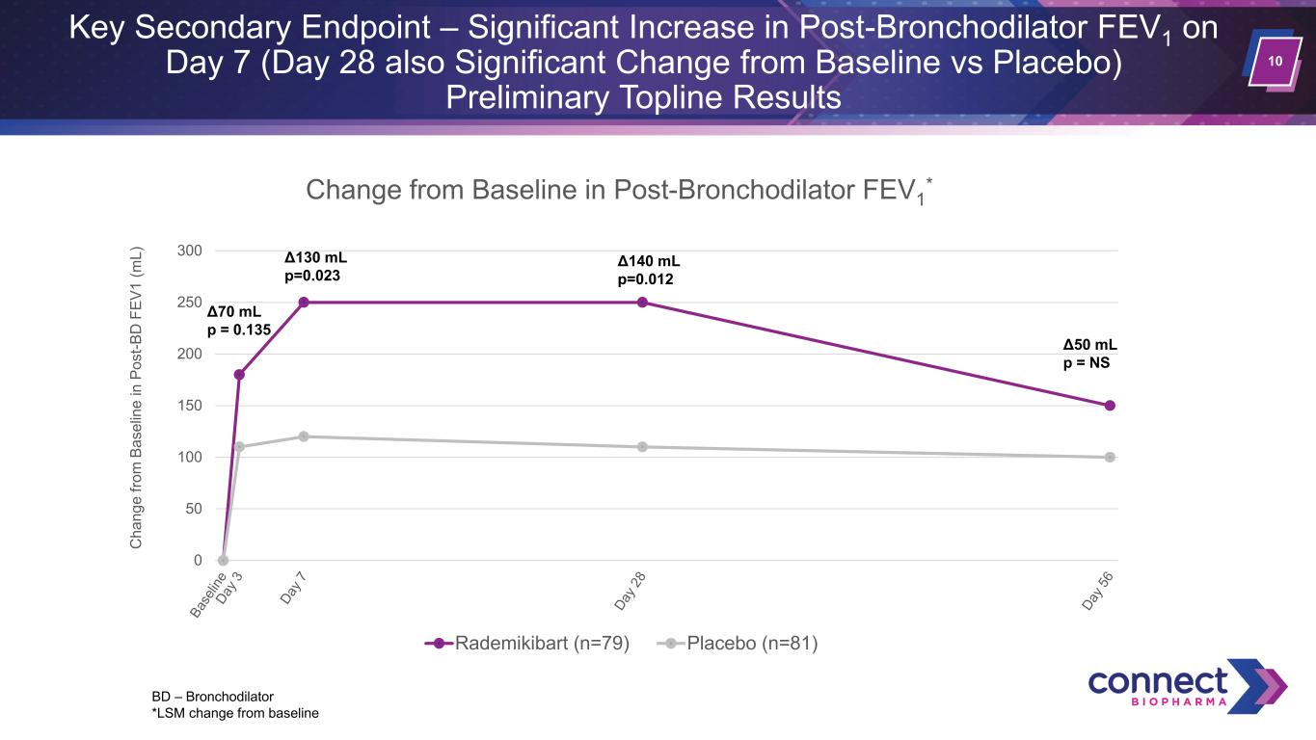
10 Key Secondary Endpoint – Significant Increase in Post-Bronchodilator FEV1 on Day 7 (Day 28 also Significant Change from Baseline vs Placebo) Preliminary Topline Results 0 50 100 150 200 250 300 C ha ng e fro m B as el in e in P os t-B D F EV 1 (m L) Change from Baseline in Post-Bronchodilator FEV1 * Rademikibart (n=79) Placebo (n=81) Δ130 mL p=0.023 Δ140 mL p=0.012 Δ70 mL p = 0.135 Δ50 mL p = NS BD – Bronchodilator *LSM change from baseline

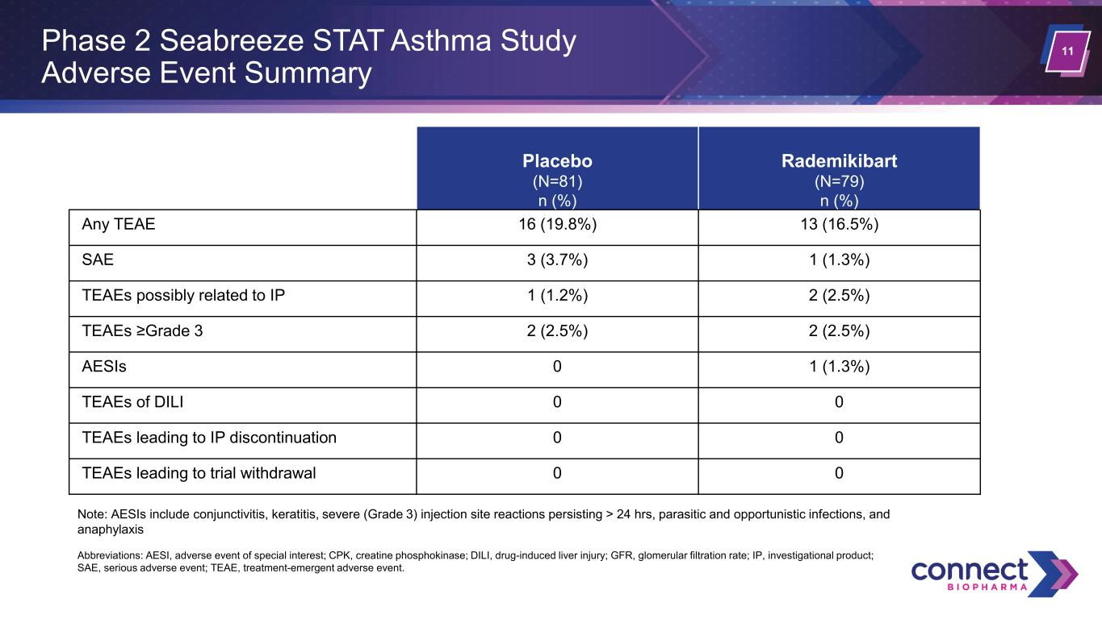
11 Placebo (N=81) n (%) Rademikibart (N=79) n (%) Any TEAE 16 (19.8%) 13 (16.5%) SAE 3 (3.7%) 1 (1.3%) TEAEs possibly related to IP 1 (1.2%) 2 (2.5%) TEAEs ≥Grade 3 2 (2.5%) 2 (2.5%) AESIs 0 1 (1.3%) TEAEs of DILI 0 0 TEAEs leading to IP discontinuation 0 0 TEAEs leading to trial withdrawal 0 0 Phase 2 Seabreeze STAT Asthma Study Adverse Event Summary Note: AESIs include conjunctivitis, keratitis, severe (Grade 3) injection site reactions persisting > 24 hrs, parasitic and opportunistic infections, and anaphylaxis Abbreviations: AESI, adverse event of special interest; CPK, creatine phosphokinase; DILI, drug-induced liver injury; GFR, glomerular filtration rate; IP, investigational product; SAE, serious adverse event; TEAE, treatment-emergent adverse event.

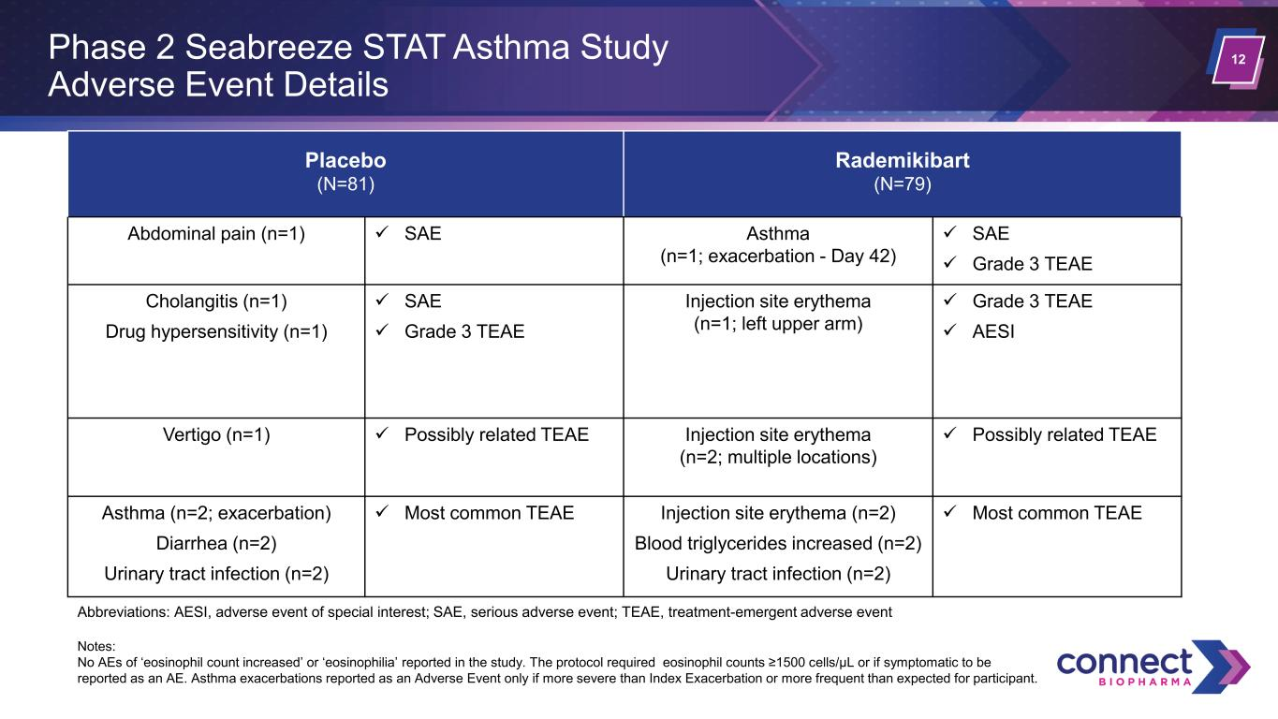
12 Placebo (N=81) Rademikibart (N=79) Abdominal pain (n=1) ✓ SAE Asthma (n=1; exacerbation - Day 42) ✓ SAE ✓ Grade 3 TEAE Cholangitis (n=1) Drug hypersensitivity (n=1) ✓ SAE ✓ Grade 3 TEAE Injection site erythema (n=1; left upper arm) ✓ Grade 3 TEAE ✓ AESI Vertigo (n=1) ✓ Possibly related TEAE Injection site erythema (n=2; multiple locations) ✓ Possibly related TEAE Asthma (n=2; exacerbation) Diarrhea (n=2) Urinary tract infection (n=2) ✓ Most common TEAE Injection site erythema (n=2) Blood triglycerides increased (n=2) Urinary tract infection (n=2) ✓ Most common TEAE Phase 2 Seabreeze STAT Asthma Study Adverse Event Details Abbreviations: AESI, adverse event of special interest; SAE, serious adverse event; TEAE, treatment-emergent adverse event Notes: No AEs of ‘eosinophil count increased’ or ‘eosinophilia’ reported in the study. The protocol required eosinophil counts ≥1500 cells/μL or if symptomatic to be reported as an AE. Asthma exacerbations reported as an Adverse Event only if more severe than Index Exacerbation or more frequent than expected for participant.

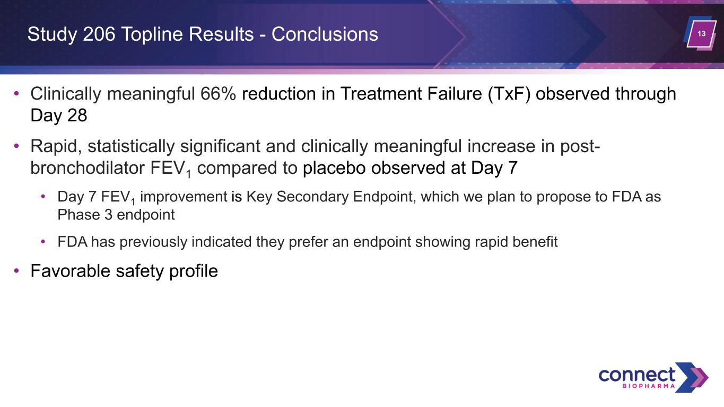
13 • Clinically meaningful 66% reduction in Treatment Failure (TxF) observed through Day 28 • Rapid, statistically significant and clinically meaningful increase in post- bronchodilator FEV1 compared to placebo observed at Day 7 • Day 7 FEV1 improvement is Key Secondary Endpoint, which we plan to propose to FDA as Phase 3 endpoint • FDA has previously indicated they prefer an endpoint showing rapid benefit • Favorable safety profile Study 206 Topline Results - Conclusions

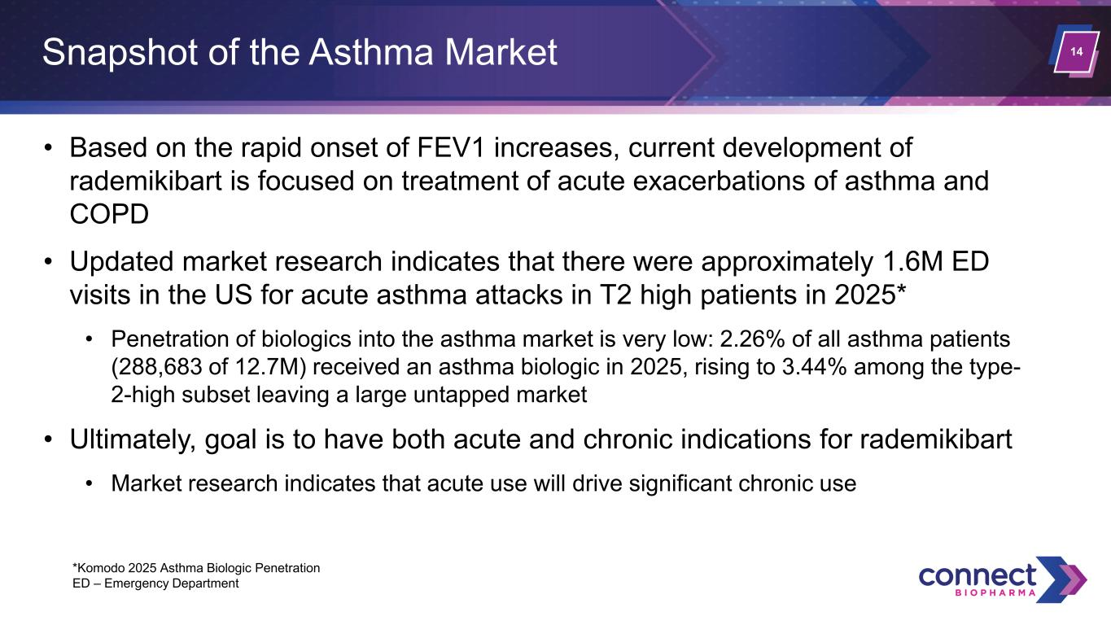
14Snapshot of the Asthma Market • Based on the rapid onset of FEV1 increases, current development of rademikibart is focused on treatment of acute exacerbations of asthma and COPD • Updated market research indicates that there were approximately 1.6M ED visits in the US for acute asthma attacks in T2 high patients in 2025* • Penetration of biologics into the asthma market is very low: 2.26% of all asthma patients (288,683 of 12.7M) received an asthma biologic in 2025, rising to 3.44% among the type- 2-high subset leaving a large untapped market • Ultimately, goal is to have both acute and chronic indications for rademikibart • Market research indicates that acute use will drive significant chronic use *Komodo 2025 Asthma Biologic Penetration ED – Emergency Department

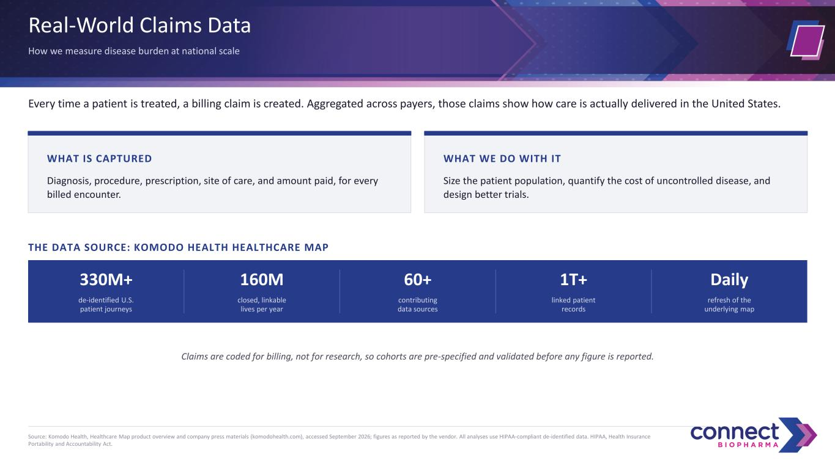
Real-World Claims Data How we measure disease burden at national scale Every time a patient is treated, a billing claim is created. Aggregated across payers, those claims show how care is actually delivered in the United States. WHAT IS CAPTURED Diagnosis, procedure, prescription, site of care, and amount paid, for every billed encounter. WHAT WE DO WITH IT Size the patient population, quantify the cost of uncontrolled disease, and design better trials. THE DATA SOURCE: KOMODO HEALTH HEALTHCARE MAP 330M+ de-identified U.S. patient journeys 160M closed, linkable lives per year 60+ contributing data sources 1T+ linked patient records Daily refresh of the underlying map Claims are coded for billing, not for research, so cohorts are pre-specified and validated before any figure is reported. Source: Komodo Health, Healthcare Map product overview and company press materials (komodohealth.com), accessed September 2026; figures as reported by the vendor. All analyses use HIPAA-compliant de-identified data. HIPAA, Health Insurance Portability and Accountability Act.

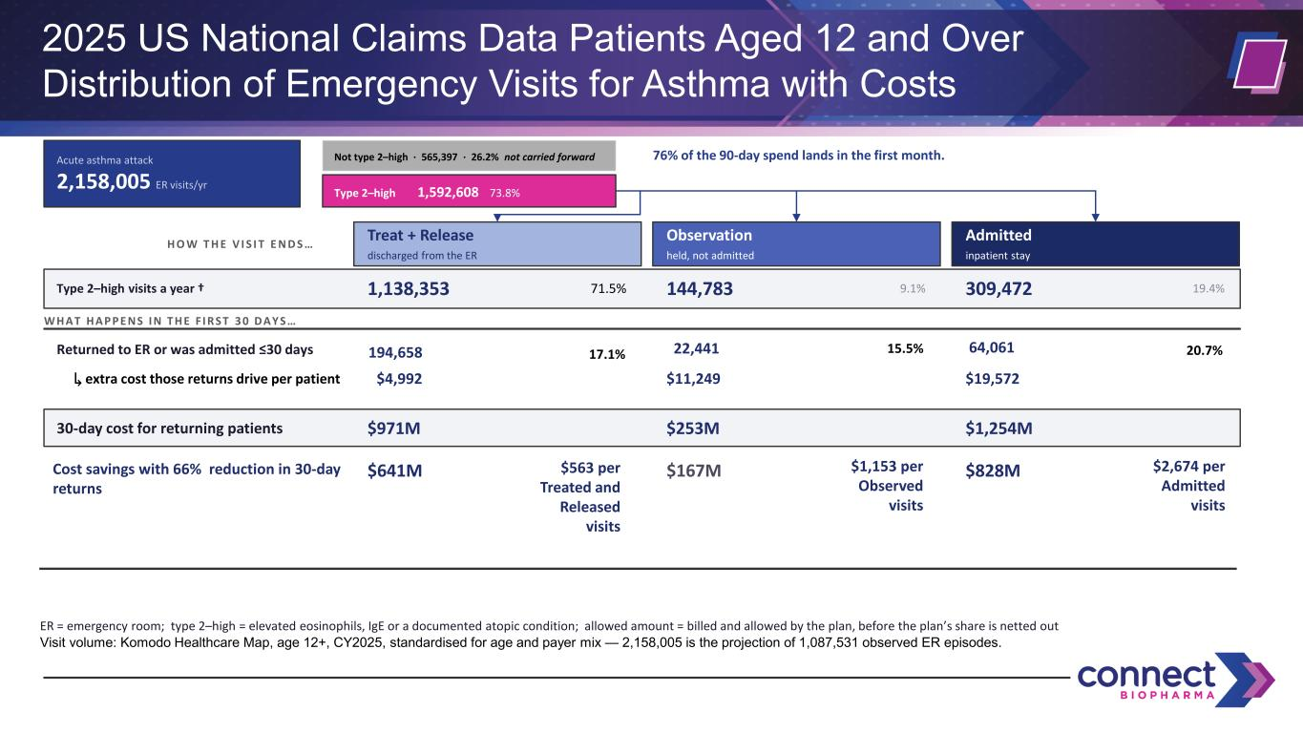
2025 US National Claims Data Patients Aged 12 and Over Distribution of Emergency Visits for Asthma with Costs Acute asthma attack 2,158,005 ER visits/yr Not type 2–high · 565,397 · 26.2% not carried forward Type 2–high 1,592,608 73.8% 76% of the 90-day spend lands in the first month. H O W T H E V I S I T E N D S … Treat + Release discharged from the ER Observation held, not admitted Admitted inpatient stay Type 2–high visits a year † 1,138,353 71.5% 144,783 9.1% 309,472 19.4% W H A T H A P P E N S I N T H E F I R S T 3 0 D A Y S … Returned to ER or was admitted ≤30 days 17.1%194,658 15.5%22,441 20.7%64,061 ↳ extra cost those returns drive per patient $4,992 $11,249 $19,572 30-day cost for returning patients $971M $253M $1,254M Cost savings with 66% reduction in 30-day returns $641M $563 per Treated and Released visits $167M $1,153 per Observed visits $828M $2,674 per Admitted visits ER = emergency room; type 2–high = elevated eosinophils, IgE or a documented atopic condition; allowed amount = billed and allowed by the plan, before the plan’s share is netted out Visit volume: Komodo Healthcare Map, age 12+, CY2025, standardised for age and payer mix — 2,158,005 is the projection of 1,087,531 observed ER episodes.

