UNITED STATES
SECURITIES AND EXCHANGE COMMISSION
WASHINGTON, D.C. 20549
________________________________________
FORM 8-K
________________________________________
CURRENT REPORT
Pursuant to Section 13 or 15(d) of the Securities Exchange Act of 1934
Date of Report (Date of earliest event reported): September 30, 2026
________________________________________
Connect Biopharma Holdings Limited
(Exact name of Registrant as Specified in Its Charter)
________________________________________
Cayman Islands |  |  | 001-40212 |  |  | Not Applicable
(State or Other Jurisdiction  of Incorporation) |  |  | (Commission File Number) |  |  | (IRS Employer  Identification No.)
 |  |  | 3580 Carmel Mountain Road, Suite 200
 |  |  | San Diego, California |  |  | 92130
 |  |  | (Address of Principal Executive Offices) |  |  | (Zip Code)
Registrant’s Telephone Number, Including Area Code: (877) 245-2787
________________________________________
Check the appropriate box below if the Form 8-K filing is intended to simultaneously satisfy the filing obligation of the registrant under any of the following provisions:
o |  |  | Written communications pursuant to Rule 425 under the Securities Act (17 CFR 230.425)
o |  |  | Soliciting material pursuant to Rule 14a-12 under the Exchange Act (17 CFR 240.14a-12)
o |  |  | Pre-commencement communications pursuant to Rule 14d-2(b) under the Exchange Act (17 CFR 240.14d-2(b))
o |  |  | Pre-commencement communications pursuant to Rule 13e-4(c) under the Exchange Act (17 CFR 240.13e-4(c))
Securities registered pursuant to Section 12(b) of the Act:
Title of each class |  |  |  |  |  | Trading  Symbol(s) |  |  |  |  |  | Name of each exchange on which registered
Ordinary Shares, par value $0.000174 per Share |  |  |  |  |  | CNTB |  |  |  |  |  | The Nasdaq Global Market
Indicate by check mark whether the registrant is an emerging growth company as defined in Rule 405 of the Securities Act of 1933 (§ 230.405 of this chapter) or Rule 12b-2 of the Securities Exchange Act of 1934 (§ 240.12b-2 of this chapter).
Emerging growth company ☒
If an emerging growth company, indicate by check mark if the registrant has elected not to use the extended transition period for complying with any new or revised financial accounting standards provided pursuant to Section 13(a) of the Exchange Act. o

Item 7.01 Regulation FD Disclosure.
Press Release.
On September 30, 2026, Connect Biopharma Holdings Limited (the “Company”) issued a press release announcing topline results from its global phase 2 study evaluating rademikibart, the Company’s next-generation, potentially best-in-class anti-interleukin-4-receptor alpha antibody as an add-on treatment for acute exacerbations in adult participants with chronic obstructive pulmonary disease (“COPD”) and type 2 inflammation (the “COPD Study”). A copy of the press release is attached as Exhibit 99.1 and is incorporated herein by reference.
Corporate Presentation.
A copy of presentation materials related to the COPD Study, all or a part of which may be used by the Company in investor or scientific presentations from time to time, is furnished herewith as Exhibit 99.2 (the “Corporate Presentation”). The Company does not undertake any obligation to update the Corporate Presentation.
The information in this Item 7.01, including in Exhibit 99.1 and Exhibit 99.2, shall not be deemed “filed” for purposes of Section 18 of the Securities Exchange Act of 1934, as amended (the “Exchange Act”), or otherwise subject to the liabilities of that section, nor shall it be deemed incorporated by reference in any filing under the Securities Act of 1933, as amended, or the Exchange Act, whether made before or after the date hereof, except as expressly set forth by specific reference in such filing.

Item 8.01 Other Events.
On September 30, 2026, the Company announced topline results for the COPD Study.
The COPD Study is a randomized, double-blind, placebo-controlled study evaluating the safety and efficacy of rademikibart as an adjunct to standard of care for acute exacerbations in participants with COPD and type 2 inflammation. The study enrolled 159 participants globally with an eosinophil count of ≥300 cells/μL who have experienced an acute COPD exacerbation. Participants were randomized 1:1 to receive either a single dose of rademikibart or placebo, administered subcutaneously in addition to standard of care. The primary endpoint was treatment failure, defined as death due to any cause, (re)admission to a hospital for COPD, emergency department (re)visit or unscheduled medical visit for worsening of COPD symptoms, or the necessity to intensify pharmacologic treatment within 28 days after randomization. Secondary endpoints included post-bronchodilator (“post-BD”) forced expiratory volume in one second (“FEV1”) at Week 1 (key secondary), rate and time to new moderate and severe COPD exacerbations, change-from-baseline in clinical respiratory symptoms of COPD, post-BD FEV1 at other timepoints, and incidence of adverse events for 8 weeks after dosing.
Key topline results include:
•Rademikibart significantly reduced the rate of treatment failure by 81% through Week 4 compared to placebo (p=0.0122)
•Rademikibart significantly reduced the rate of new moderate to severe COPD exacerbations by 85% through Week 4 compared to placebo (p=0.030)
•Rademikibart significantly reduced new visits to emergency departments and hospital admissions for new exacerbations by 100% through Week 4 compared to placebo (p=0.0137)
•Rademikibart significantly reduced the use of rescue inhalers from Week 2 through Week 7 and significantly improved COPD symptoms at Week 2 compared to placebo (Total Score, p=0.0197)
•Clinically meaningful 70 mL greater improvement in FEV1 at Week 4 with rademikibart compared to placebo (p=0.1607)
•Rademikibart was well tolerated and no new safety signals were observed through the end of the study. The safety profile was comparable to placebo, with a lower incidence of adverse events and serious adverse events reported in the rademikibart arm compared to the placebo arm.

Item 9.01 Financial Statements and Exhibits.
(d) Exhibits
Exhibit No. |  |  |  |  |  | Description
99.1 |  |  |  |  |  | Press Release of the Company, dated September 30, 2026
99.2 |  |  |  |  |  | Corporate Presentation, dated September 30, 2026
104 |  |  |  |  |  | Cover Page Interactive Data File (embedded within the Inline XBRL document)

Forward-Looking Statements
The Company cautions you that statements contained in this Current Report on Form 8-K, including in the exhibits furnished herewith, regarding matters that are not historical facts are forward-looking statements. The forward-looking statements are based on our current beliefs and expectations and include, but are not limited to, statements regarding: our future financial and operating results and related expectations, business strategy and plans, prospective products (as well as their potential to achieve a differentiated, competitive, or favorable benefit or profile or trend, including on safety, tolerability, improvement, maintenance, clinical response, dosing, efficacy and/or convenience), statements regarding the timing or results of any interim analysis or interim, topline or preliminary data and whether such analysis or data is indicative of safety, efficacy, final trial results or likelihood of regulatory approval for our product candidates, planned or expected meetings with the U.S. Food and Drug Administration (“FDA”) or any other regulatory authorities, planned or expected product approval applications or approvals, anticipated milestones and milestone payments, expected data readouts and enrollments and the timing thereof, research and development plans and costs including expectations for future clinical studies, potential future partnerships, expectations about existing partnerships, timing and likelihood of success, objectives of management for future operations, future results of anticipated product development efforts, adequacy of existing cash and potential partnership funding to fund operations and capital expenditure requirements, anticipated patient populations, market opportunities and potential pricing strategies for our prospective products, if approved, our plans for rademikibart, including potential indications, as well as statements regarding industry trends. The inclusion of forward-looking statements should not be regarded as a representation by the Company that any of these plans will be achieved. Actual results may differ from those set forth in this Current Report on Form 8-K due to the risks and uncertainties inherent in the Company’s business and beyond its control, including, without limitation: the ability of our clinical trials to demonstrate safety and efficacy of our product candidates and other positive results; whether we will need expanded or additional trials in order to obtain regulatory approval for our product candidates; the timing and outcome of any meetings with the FDA or other regulatory authorities regarding further development of our product candidates, including with respect to a potential Phase 3 program for rademikibart; our ability to obtain and maintain regulatory approval of our product candidates; existing regulations and regulatory developments in the U.S., the People’s Republic of China, Europe and other jurisdictions; our plans and ability to obtain, maintain, protect and enforce our intellectual property rights and our proprietary technologies, including extensions of existing patent terms where available; our continued reliance on third parties to conduct additional clinical trials of our product candidates, and for the manufacture of our product candidates for preclinical studies and clinical trials; the degree of market acceptance of our product candidates, if approved, by physicians, patients, healthcare payors and others in the medical community; the impact on our business of adverse global macroeconomic and geopolitical conditions, including high interest rates, the inflationary environment, recessionary fears, foreign exchange rate volatility, instability in financial institutions, government shutdowns, changes in monetary policy, changes in trade policies, including tariffs and other trade restrictions or the threat of such actions, and rising geopolitical instability, including the conflicts in the Middle East and the related volatility in the price of oil and other commodity prices; and other risks described in our Annual Report on Form 10-K for the fiscal year ended December 31, 2025, and in any subsequent filings with the SEC. You are cautioned not to place undue reliance on these forward-looking statements, which speak only as of the date hereof, and we undertake no obligation to update such statements to reflect events that occur or circumstances that exist after the date hereof. All forward-looking statements are qualified in their entirety by this cautionary statement, which is made under the safe harbor provisions of the Private Securities Litigation Reform Act of 1995.

SIGNATURES
Pursuant to the requirements of the Securities Exchange Act of 1934, the registrant has duly caused this report to be signed on its behalf by the undersigned hereunto duly authorized.
 |  |  |  |  |  |  |  |  | CONNECT BIOPHARMA HOLDINGS LIMITED
Date: |  |  | September 30, 2026 |  |  | By: |  |  | /s/ David Szekeres
 |  |  |  |  |  | Name: |  |  | David Szekeres
 |  |  |  |  |  | Title: |  |  | President

Exhibit 99.1

Connect Biopharma Announces Positive Preliminary Topline Data from its Global Phase 2 Study of Rademikibart as an Add-on Treatment for Acute Exacerbations in Adults with COPD and Type 2 Inflammation

– Rademikibart significantly reduced the rate of treatment failure compared to placebo through one month by 81% (p=0.0122) –
– Rademikibart significantly reduced the rate of new moderate to severe COPD exacerbations through one month by 85% (p=0.030) –
– Rademikibart significantly reduced the rate of hospitalizations or emergency department visits for new acute COPD exacerbations by 100% (p=0.0137) –
– Rademikibart was well tolerated in COPD patients experiencing an acute exacerbation with a lower incidence of adverse events than placebo –
– Connect plans to engage with the U.S. Food and Drug Administration (FDA) to gain alignment on a Phase 3 program –
– Company to host a conference call to discuss the data today, September 30 at 8:00 a.m. ET –
SAN DIEGO, SEPTEMBER 30, 2026 (GLOBE NEWSWIRE) -- Connect Biopharma Holdings Limited (Nasdaq: CNTB) (Connect Biopharma, Connect or the Company), a clinical-stage biopharmaceutical company focused on transforming care for the treatment of inflammatory diseases, today announced topline results from its global Phase 2 study evaluating rademikibart, the Company’s next-generation, potentially best-in-class anti-interleukin-4-receptor alpha (IL-4Rα) antibody as an add-on treatment for acute exacerbations in adult participants with chronic obstructive pulmonary disease (COPD) and type 2 inflammation.

“Topline data from our Seabreeze STAT COPD trial for rademikibart provides overwhelming evidence of the potential benefit early treatment with rademikibart may provide to COPD patients experiencing an acute exacerbation,” said Barry Quart, Pharm.D., CEO and Director of Connect Biopharma. “2025 claims data indicate that COPD patients going to the emergency department (ED) due to an acute exacerbation generate approximately $6 billion in healthcare costs in the following 30 days due to return visits to the ED or hospital. This study demonstrated that rademikibart completely eliminated those return visits while decreasing new moderate to severe COPD exacerbations by 85% compared to placebo. These groundbreaking results provide a unique opportunity to differentiate rademikibart in COPD from all other approved biologics. We plan to engage with the FDA as soon as feasible regarding a Phase 3 registrational development program for rademikibart as add-on treatment for COPD.”

“Acute exacerbations continue to be a major driver of morbidity in COPD, and there remains a need for therapies that can improve outcomes following these events,” said Surya Bhatt, MD, Director of the University of Alabama at Birmingham, UAB Center for Lung Analytics and Imaging Research (CLAIR) in Birmingham, Alabama. “The reduction in COPD exacerbations is compelling, and the clinically meaningful increase in pulmonary function provides a very important improvement over standard-of-care and supports the potential for rademikibart to improve outcomes for COPD patients following an acute exacerbation and for chronic maintenance.”

Mario Castro MD, MPH, Professor of Medicine and Chief of the Division of Pulmonary, Critical Care and Sleep Medicine at the University of Kansas School of Medicine added, “One of the

greatest challenges in COPD management is helping patients recover from an acute exacerbation and remain stable once they leave the hospital. The reductions in hospitalizations seen with rademikibart address a critical period when patients are at particularly high risk for worsening disease. By helping stabilize patients during the vulnerable post-exacerbation period, rademikibart has the potential to provide benefit in both acute and long-term disease management and meaningfully improve patient care.”

The Phase 2 Seabreeze STAT COPD study (CBP-201-207) is a randomized, double-blind, placebo-controlled study evaluating the safety and efficacy of rademikibart as an adjunct to standard of care for acute exacerbations in participants with COPD and type 2 inflammation. The study enrolled 159 participants globally with an eosinophil count of ≥300 cells/μL who have experienced an acute COPD exacerbation. Participants were randomized 1:1 to receive either a single dose of rademikibart or placebo, administered subcutaneously in addition to standard of care. The primary endpoint was treatment failure, defined as death due to any cause, (re)admission to a hospital for COPD, emergency department (ED) (re)visit or unscheduled medical visit for worsening of COPD symptoms, or the necessity to intensify pharmacologic treatment within 28 days after randomization. Secondary endpoints included post-bronchodilator (post-BD) FEV1 at Week 1 (key secondary), rate and time to new moderate and severe COPD exacerbations, change-from-baseline in clinical respiratory symptoms of COPD, post-BD FEV1 at other timepoints, and incidence of adverse events for 8 weeks after dosing. For more information, please visit clinicaltrials.gov (identifier NCT06940154).
Key topline results include:
•Rademikibart significantly reduced the rate of treatment failure by 81% through Week 4 compared to placebo (p=0.0122)
•Rademikibart significantly reduced the rate of new moderate to severe COPD exacerbations by 85% through Week 4 compared to placebo (p=0.030)
•Rademikibart significantly reduced new visits to emergency departments and hospital admissions for new exacerbations by 100% through Week 4 compared to placebo (p=0.0137)
•Rademikibart significantly reduced the use of rescue inhalers from Week 2 through Week 7 and significantly improved COPD symptoms at Week 2 compared to placebo (Total Score, p=0.0197)
•Clinically meaningful 70 mL greater improvement in FEV1 at Week 4 with rademikibart compared to placebo (p=0.1607)
•Rademikibart was well tolerated and no new safety signals were observed through the end of the study. The safety profile was comparable to placebo, with a lower incidence of adverse events and serious adverse events reported in the rademikibart arm compared to the placebo arm.

Company-Hosted Conference Call and Webcast

Connect will host a conference call and webcast today, September 30, 2026, at 8:00 a.m. ET. To access the conference call, please pre-register through here to receive dial-in information and a personal PIN to access the live call. Participants may access the live webcast here or from the Investors section of the Connect website at investors.connectbiopharma.com. An archive of the webcast and presentation will be available for approximately 90 days after the event.

About Rademikibart

Rademikibart is a fully human monoclonal antibody targeting interleukin-4 receptor alpha (IL-4Rα), a common subunit of interleukin-4 receptor (IL-4) and interleukin-13 receptor (IL-13). We believe that by binding with IL-4Rα, rademikibart can block the functions of IL-4 and IL-13 effectively, thereby blocking the T helper 2 (Th2) inflammatory pathway to achieving the goal of treating Th2 related inflammatory diseases such as atopic dermatitis, asthma and COPD.

About Connect Biopharma

Connect Biopharma is a clinical-stage biopharmaceutical company dedicated to transforming care for asthma and COPD. Headquartered in San Diego, California, the Company is advancing rademikibart, a next-generation, potentially best-in-class antibody designed to target IL-4Rα. The Company is currently conducting global clinical studies of rademikibart for the treatment of acute exacerbations of asthma and COPD, areas with significant unmet need. Connect has granted an exclusive license to Simcere Pharmaceutical Co., Ltd., for rademikibart in Greater China. Under the exclusive license and collaboration agreement, Connect is eligible to receive remaining milestone payments up to an aggregate amount of approximately $99 million upon the achievement of certain development, regulatory and commercial milestones. Connect is also eligible to receive royalties at tiered percentage rates up to low double-digit percentages on net sales in Greater China.

For more information visit www.connectbiopharma.com.

Forward-Looking Statements

This press release contains “forward-looking statements” within the meaning of the Private Securities Litigation Reform Act of 1995, as amended. Forward-looking statements are statements that are not of historical fact and include, without limitation, statements regarding future events, our future financial and operating results and related expectations, business strategy and plans, prospective products (as well as their potential to achieve a differentiated, competitive, or favorable benefit or profile or trend, including on safety, tolerability, improvement, maintenance, clinical response, dosing, efficacy and/or convenience), statements regarding the timing or results of any interim analysis or interim, topline or preliminary data and whether such analysis or data is indicative of safety, efficacy, final trial results or likelihood of regulatory approval for our product candidates, planned or expected meetings with the FDA or any other regulatory authorities, planned or expected product approval applications or approvals, anticipated milestones and milestone payments, expected data readouts and enrollments and the timing thereof, research and development plans and costs, potential future partnerships, expectations about existing partnerships, timing and likelihood of success, objectives of management for future operations, future results of anticipated product development efforts, adequacy of existing cash and potential partnership funding to fund operations and capital expenditure requirements, anticipated patient populations, market opportunities and potential pricing strategies for our prospective products, if approved, our plans for rademikibart, including potential indications, as well as statements regarding industry trends. These statements are based on management’s current expectations of future events only as of the date of this press release and are inherently subject to a number of risks, uncertainties and assumptions, some of which cannot be predicted or quantified and some of which are beyond our control, including,

among other things: the ability of our clinical trials to demonstrate safety and efficacy of our product candidates and other positive results; whether we will need expanded or additional trials in order to obtain regulatory approval for our product candidates; the timing and outcome of any meetings with the FDA or other regulatory authorities regarding further development of our product candidates, including with respect to a potential Phase 3 program for rademikibart; our ability to obtain and maintain regulatory approval of our product candidates; existing regulations and regulatory developments in the U.S., the People’s Republic of China, Europe and other jurisdictions; our plans and ability to obtain, maintain, protect and enforce our intellectual property rights and our proprietary technologies, including extensions of existing patent terms where available; our continued reliance on third parties to conduct additional clinical trials of our product candidates, and for the manufacture of our product candidates for preclinical studies and clinical trials; the degree of market acceptance of our product candidates, if approved, by physicians, patients, healthcare payors and others in the medical community; the impact on our business of adverse global macroeconomic and geopolitical conditions, including high interest rates, the inflationary environment, recessionary fears, foreign exchange rate volatility, instability in financial institutions, government shutdowns, changes in monetary policy, changes in trade policies, including tariffs and other trade restrictions or the threat of such actions, and rising geopolitical instability, including the conflicts in the Middle East and the related volatility in the price of oil and other commodity prices; as well as the risks and uncertainties described in Part I, “Item 1A. Risk Factors” of our Annual Report on Form 10-K for the year ended December 31, 2025, our subsequent Quarterly Reports on Form 10-Q and our other filings with the SEC .

Words such as “aim,” “anticipate,” “believe,” “commitments,” “continue,” “could,” “design,” “estimate,” “expect,” “feel,” “goal,” “intend,” “may,” “might,” “objective,” “optimistic,” “plan,” “potential,” “predict,” “promising,” “seek,” “should,” “target,” “will,” “would,” and similar expressions are intended to identify forward-looking statements, though not all forward-looking statements necessarily contain these identifying words. The inclusion of forward-looking statements should not be regarded as a representation by Connect Biopharma that any of its expectations, projections or plans will be achieved. Actual results or outcomes, or the timing of such results or outcomes, may differ materially from those expressed or implied in our forward-looking statements due to the risks and uncertainties described above. These forward-looking statements should not be taken as forecasts or promises nor should they be taken as implying any indication, assurance or guarantee that the assumptions on which such forward-looking statements have been made are correct or exhaustive or, in the case of the assumptions, fully stated herein. Drug development and commercialization involve a high degree of risk, and only a small number of research and development programs result in commercialization of a product. Results in early-stage clinical trials may not be indicative of full results or results from later stage or larger scale clinical trials and do not ensure regulatory approval. You are cautioned not to place undue reliance on the scientific data presented or these forward-looking statements, which speak only as of the date hereof. Except as required by law, Connect Biopharma undertakes no obligation to publicly update any forward-looking statements, whether because of new information, future events or otherwise.

This press release discusses our product candidate, rademikibart, which is under clinical investigation and has not yet been approved for marketing by the FDA, the National Medical Products Administration, or by any other regulatory agency. No representation is made as to the safety or effectiveness of rademikibart for the uses for which it is being studied. The trademarks included herein are the property of the owners thereof and are used for reference purposes only.

Investor Relations Contact:

Alex Lobo
Precision AQ
Alex.lobo@precisionaq.com
(212) 698-8802

Media Contact:

Ignacio Guerrero-Ros, Ph.D., or David Schull
Russo Partners, LLC
Ignacio.guerrero-ros@russopartnersllc.com
David.schull@russopartnersllc.com
(858) 717-2310 or (646) 942-5604
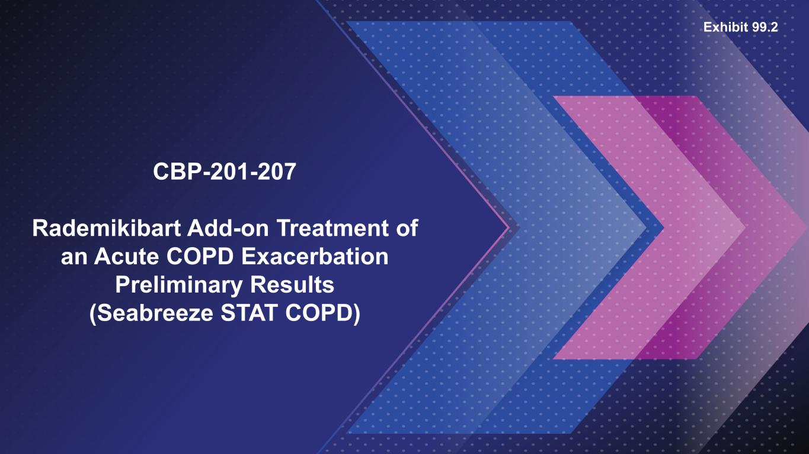

CBP-201-207 Rademikibart Add-on Treatment of an Acute COPD Exacerbation Preliminary Results (Seabreeze STAT COPD) Exhibit 99.2

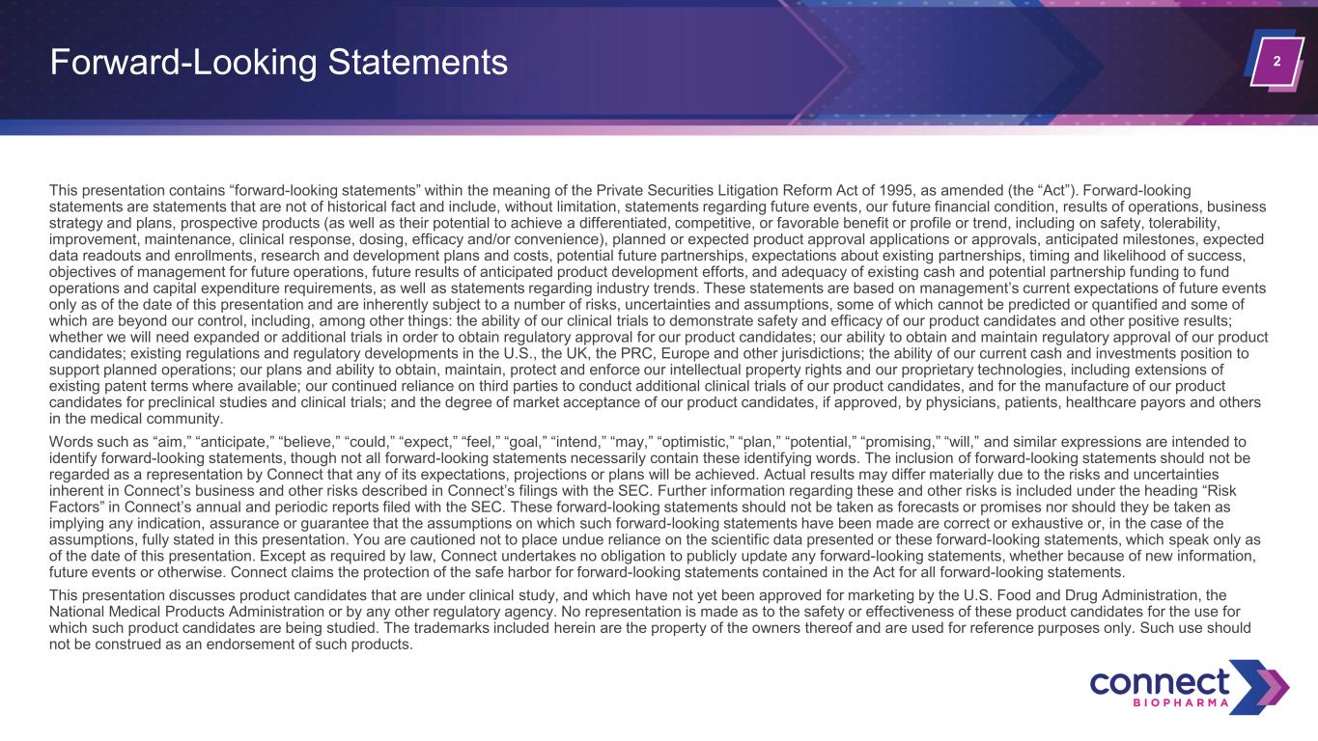
2 This presentation contains “forward-looking statements” within the meaning of the Private Securities Litigation Reform Act of 1995, as amended (the “Act”). Forward-looking statements are statements that are not of historical fact and include, without limitation, statements regarding future events, our future financial condition, results of operations, business strategy and plans, prospective products (as well as their potential to achieve a differentiated, competitive, or favorable benefit or profile or trend, including on safety, tolerability, improvement, maintenance, clinical response, dosing, efficacy and/or convenience), planned or expected product approval applications or approvals, anticipated milestones, expected data readouts and enrollments, research and development plans and costs, potential future partnerships, expectations about existing partnerships, timing and likelihood of success, objectives of management for future operations, future results of anticipated product development efforts, and adequacy of existing cash and potential partnership funding to fund operations and capital expenditure requirements, as well as statements regarding industry trends. These statements are based on management’s current expectations of future events only as of the date of this presentation and are inherently subject to a number of risks, uncertainties and assumptions, some of which cannot be predicted or quantified and some of which are beyond our control, including, among other things: the ability of our clinical trials to demonstrate safety and efficacy of our product candidates and other positive results; whether we will need expanded or additional trials in order to obtain regulatory approval for our product candidates; our ability to obtain and maintain regulatory approval of our product candidates; existing regulations and regulatory developments in the U.S., the UK, the PRC, Europe and other jurisdictions; the ability of our current cash and investments position to support planned operations; our plans and ability to obtain, maintain, protect and enforce our intellectual property rights and our proprietary technologies, including extensions of existing patent terms where available; our continued reliance on third parties to conduct additional clinical trials of our product candidates, and for the manufacture of our product candidates for preclinical studies and clinical trials; and the degree of market acceptance of our product candidates, if approved, by physicians, patients, healthcare payors and others in the medical community. Words such as “aim,” “anticipate,” “believe,” “could,” “expect,” “feel,” “goal,” “intend,” “may,” “optimistic,” “plan,” “potential,” “promising,” “will,” and similar expressions are intended to identify forward-looking statements, though not all forward-looking statements necessarily contain these identifying words. The inclusion of forward-looking statements should not be regarded as a representation by Connect that any of its expectations, projections or plans will be achieved. Actual results may differ materially due to the risks and uncertainties inherent in Connect’s business and other risks described in Connect’s filings with the SEC. Further information regarding these and other risks is included under the heading “Risk Factors” in Connect’s annual and periodic reports filed with the SEC. These forward-looking statements should not be taken as forecasts or promises nor should they be taken as implying any indication, assurance or guarantee that the assumptions on which such forward-looking statements have been made are correct or exhaustive or, in the case of the assumptions, fully stated in this presentation. You are cautioned not to place undue reliance on the scientific data presented or these forward-looking statements, which speak only as of the date of this presentation. Except as required by law, Connect undertakes no obligation to publicly update any forward-looking statements, whether because of new information, future events or otherwise. Connect claims the protection of the safe harbor for forward-looking statements contained in the Act for all forward-looking statements. This presentation discusses product candidates that are under clinical study, and which have not yet been approved for marketing by the U.S. Food and Drug Administration, the National Medical Products Administration or by any other regulatory agency. No representation is made as to the safety or effectiveness of these product candidates for the use for which such product candidates are being studied. The trademarks included herein are the property of the owners thereof and are used for reference purposes only. Such use should not be construed as an endorsement of such products. Forward-Looking Statements

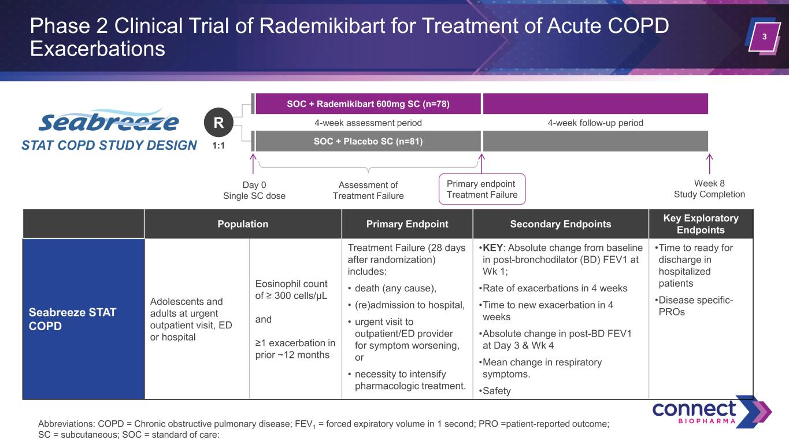
3 Phase 2 Clinical Trial of Rademikibart for Treatment of Acute COPD Exacerbations Abbreviations: COPD = Chronic obstructive pulmonary disease; FEV1 = forced expiratory volume in 1 second; PRO =patient-reported outcome; SC = subcutaneous; SOC = standard of care: SOC + Placebo SC (n=81) Assessment of Treatment Failure Day 0 Single SC dose SOC + Rademikibart 600mg SC (n=78) Primary endpoint Treatment Failure 4-week follow-up period Week 8 Study Completion 4-week assessment period STAT COPD STUDY DESIGN 1:1 R Population Primary Endpoint Secondary Endpoints Key Exploratory Endpoints Seabreeze STAT COPD Adolescents and adults at urgent outpatient visit, ED or hospital Eosinophil count of ≥ 300 cells/µL and ≥1 exacerbation in prior ~12 months Treatment Failure (28 days after randomization) includes: • death (any cause), • (re)admission to hospital, • urgent visit to outpatient/ED provider for symptom worsening, or • necessity to intensify pharmacologic treatment. •KEY: Absolute change from baseline in post-bronchodilator (BD) FEV1 at Wk 1; •Rate of exacerbations in 4 weeks •Time to new exacerbation in 4 weeks •Absolute change in post-BD FEV1 at Day 3 & Wk 4 •Mean change in respiratory symptoms. •Safety •Time to ready for discharge in hospitalized patients •Disease specific- PROs

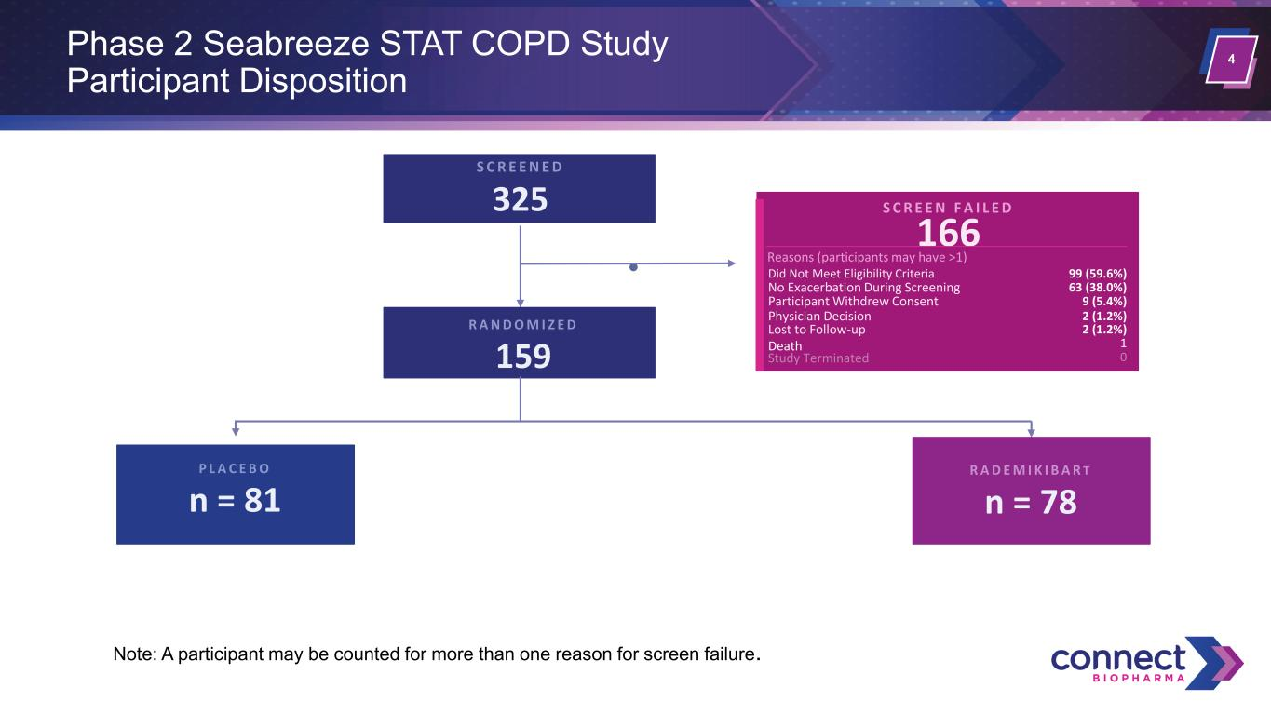
4Phase 2 Seabreeze STAT COPD Study Participant Disposition S C R E E N E D 325 S C R E E N F A I L E D 166 Reasons (participants may have >1) Did Not Meet Eligibility Criteria 99 (59.6%) No Exacerbation During Screening 63 (38.0%) Physician Decision 2 (1.2%) Participant Withdrew Consent 9 (5.4%) Lost to Follow-up 2 (1.2%) 0 Death 1 R A N D O M I Z E D 159 P L A C E B O n = 81 R A D E M I K I B A R T n = 78 Note: A participant may be counted for more than one reason for screen failure. Study Terminated

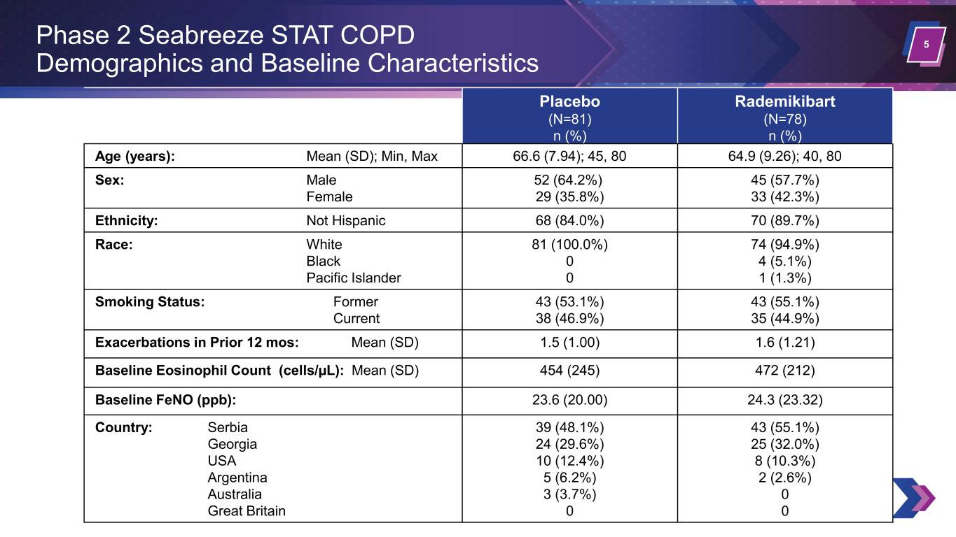
5 Placebo (N=81) n (%) Rademikibart (N=78) n (%) Age (years): Mean (SD); Min, Max 66.6 (7.94); 45, 80 64.9 (9.26); 40, 80 Sex: Male Female 52 (64.2%) 29 (35.8%) 45 (57.7%) 33 (42.3%) Ethnicity: Not Hispanic 68 (84.0%) 70 (89.7%) Race: White Black Pacific Islander 81 (100.0%) 0 0 74 (94.9%) 4 (5.1%) 1 (1.3%) Smoking Status: Former Current 43 (53.1%) 38 (46.9%) 43 (55.1%) 35 (44.9%) Exacerbations in Prior 12 mos: Mean (SD) 1.5 (1.00) 1.6 (1.21) Baseline Eosinophil Count (cells/µL): Mean (SD) 454 (245) 472 (212) Baseline FeNO (ppb): 23.6 (20.00) 24.3 (23.32) Country: Serbia Georgia USA Argentina Australia Great Britain 39 (48.1%) 24 (29.6%) 10 (12.4%) 5 (6.2%) 3 (3.7%) 0 43 (55.1%) 25 (32.0%) 8 (10.3%) 2 (2.6%) 0 0 Phase 2 Seabreeze STAT COPD Demographics and Baseline Characteristics

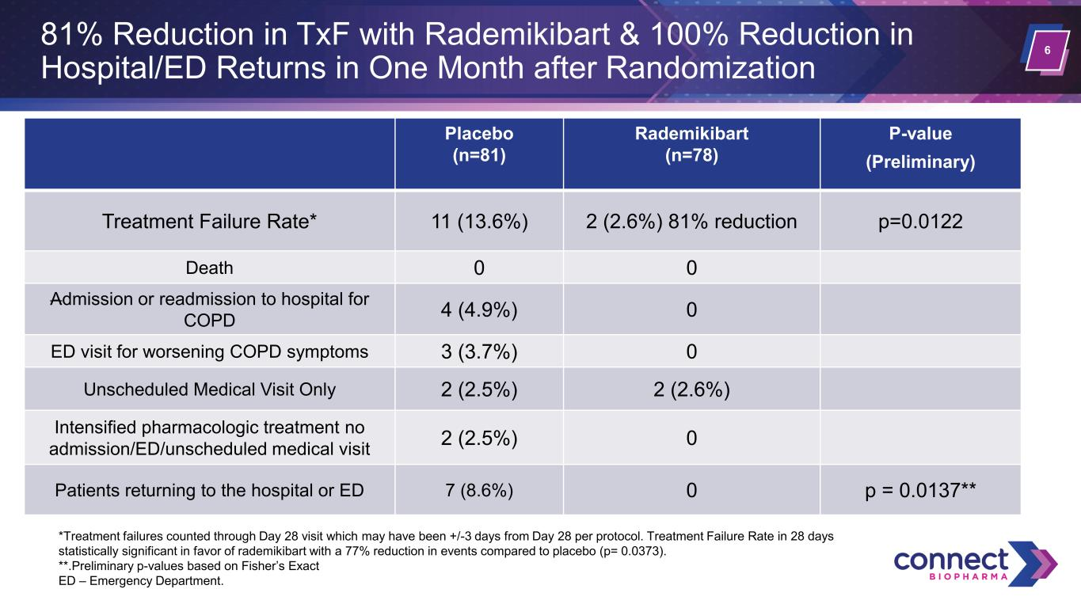
6 81% Reduction in TxF with Rademikibart & 100% Reduction in Hospital/ED Returns in One Month after Randomization Placebo (n=81) Rademikibart (n=78) P-value (Preliminary) Treatment Failure Rate* 11 (13.6%) 2 (2.6%) 81% reduction p=0.0122 Death 0 0 Admission or readmission to hospital for COPD 4 (4.9%) 0 ED visit for worsening COPD symptoms 3 (3.7%) 0 Unscheduled Medical Visit Only 2 (2.5%) 2 (2.6%) Intensified pharmacologic treatment no admission/ED/unscheduled medical visit 2 (2.5%) 0 Patients returning to the hospital or ED 7 (8.6%) 0 p = 0.0137** *Treatment failures counted through Day 28 visit which may have been +/-3 days from Day 28 per protocol. Treatment Failure Rate in 28 days statistically significant in favor of rademikibart with a 77% reduction in events compared to placebo (p= 0.0373). **.Preliminary p-values based on Fisher’s Exact ED – Emergency Department.

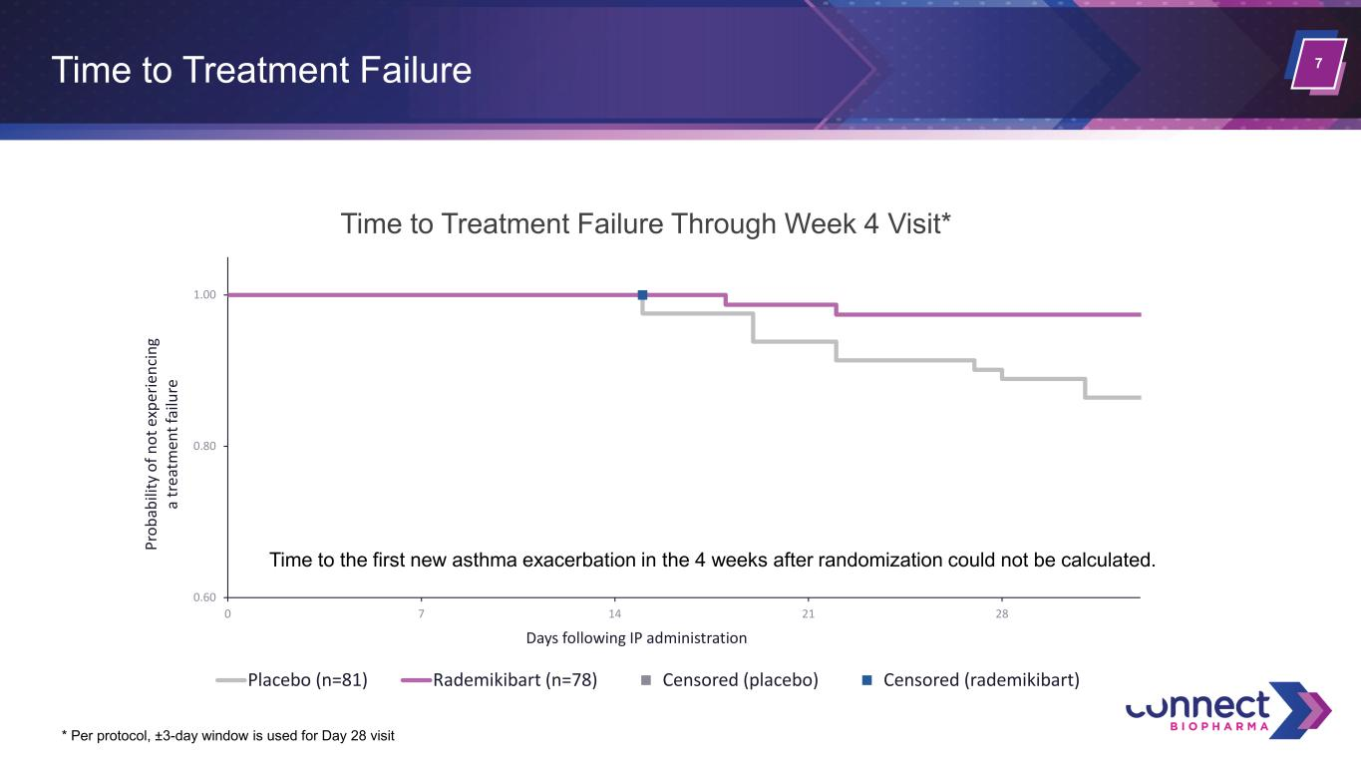
7Time to Treatment Failure 0.60 0.80 1.00 0 7 14 21 28 Pr ob ab ili ty o f n ot e xp er ie nc in g a tr ea tm en t f ai lu re Days following IP administration Time to Treatment Failure Through Week 4 Visit* Placebo (n=81) Rademikibart (n=78) Censored (placebo) Censored (rademikibart) * Per protocol, ±3-day window is used for Day 28 visit Time to the first new asthma exacerbation in the 4 weeks after randomization could not be calculated.

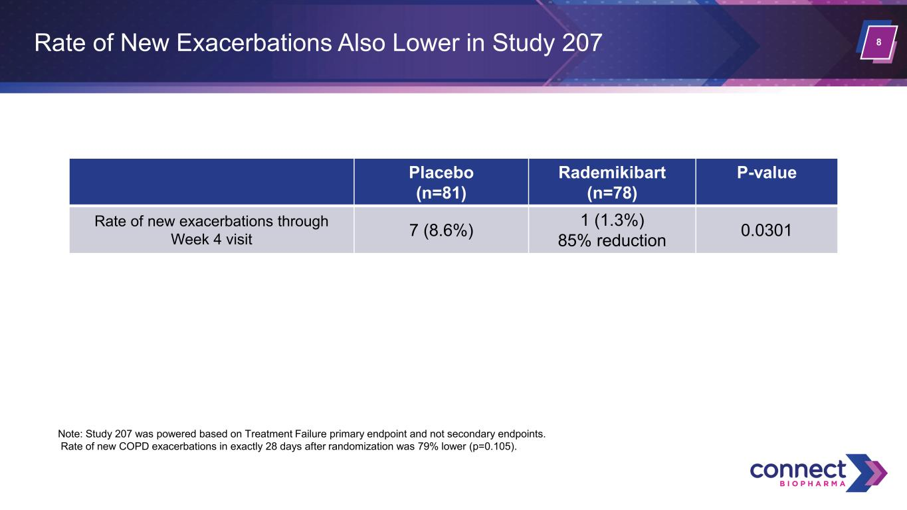
8Rate of New Exacerbations Also Lower in Study 207 Placebo (n=81) Rademikibart (n=78) P-value Rate of new exacerbations through Week 4 visit 7 (8.6%) 1 (1.3%) 85% reduction 0.0301 Note: Study 207 was powered based on Treatment Failure primary endpoint and not secondary endpoints. Rate of new COPD exacerbations in exactly 28 days after randomization was 79% lower (p=0.105).

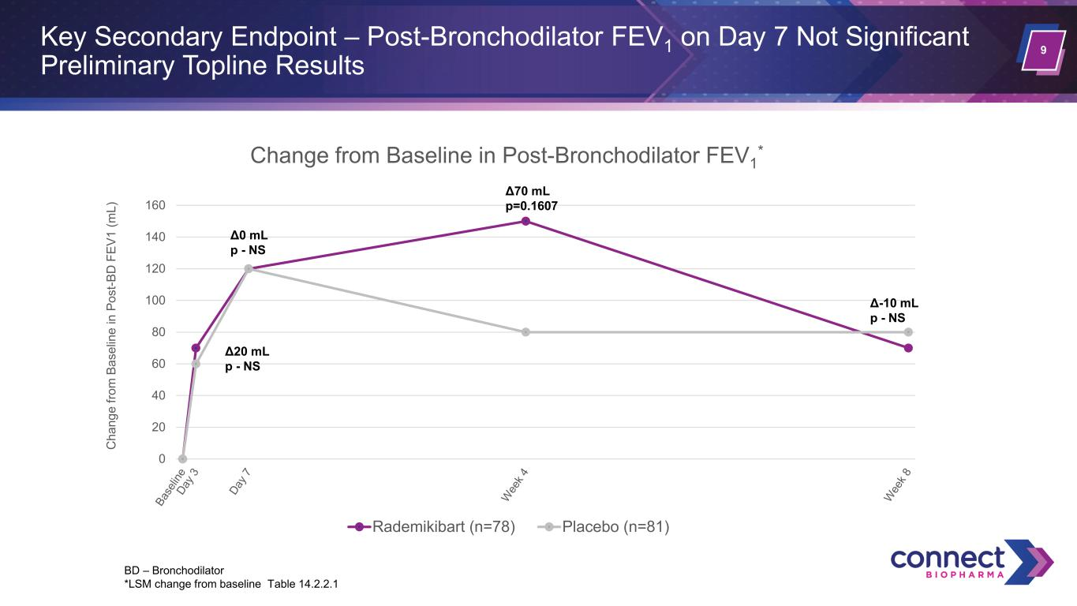
9 Key Secondary Endpoint – Post-Bronchodilator FEV1 on Day 7 Not Significant Preliminary Topline Results 0 20 40 60 80 100 120 140 160 C ha ng e fro m B as el in e in P os t-B D F EV 1 (m L) Change from Baseline in Post-Bronchodilator FEV1 * Rademikibart (n=78) Placebo (n=81) Δ0 mL p - NS Δ70 mL p=0.1607 Δ20 mL p - NS Δ-10 mL p - NS BD – Bronchodilator *LSM change from baseline Table 14.2.2.1

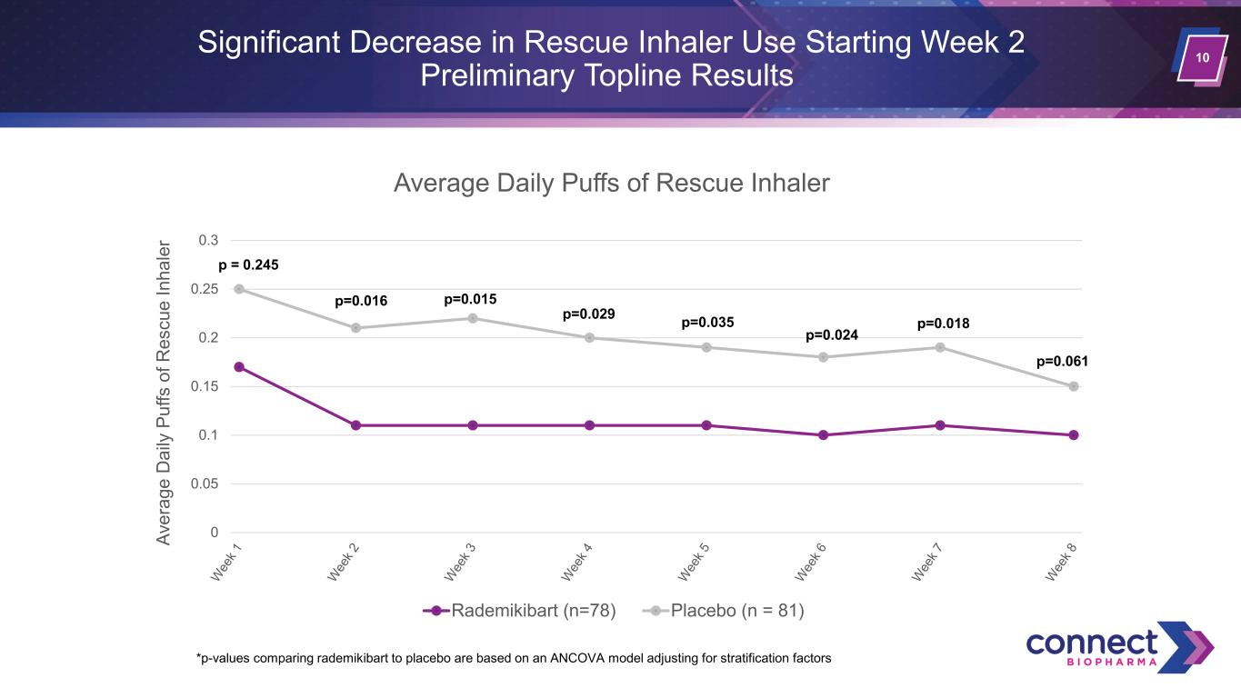
10 Significant Decrease in Rescue Inhaler Use Starting Week 2 Preliminary Topline Results 0 0.05 0.1 0.15 0.2 0.25 0.3 Av er ag e D ai ly P uf fs o f R es cu e In ha le r Average Daily Puffs of Rescue Inhaler Rademikibart (n=78) Placebo (n = 81) p=0.016 p = 0.245 *p-values comparing rademikibart to placebo are based on an ANCOVA model adjusting for stratification factors p=0.015 p=0.018 p=0.061 p=0.024 p=0.035p=0.029

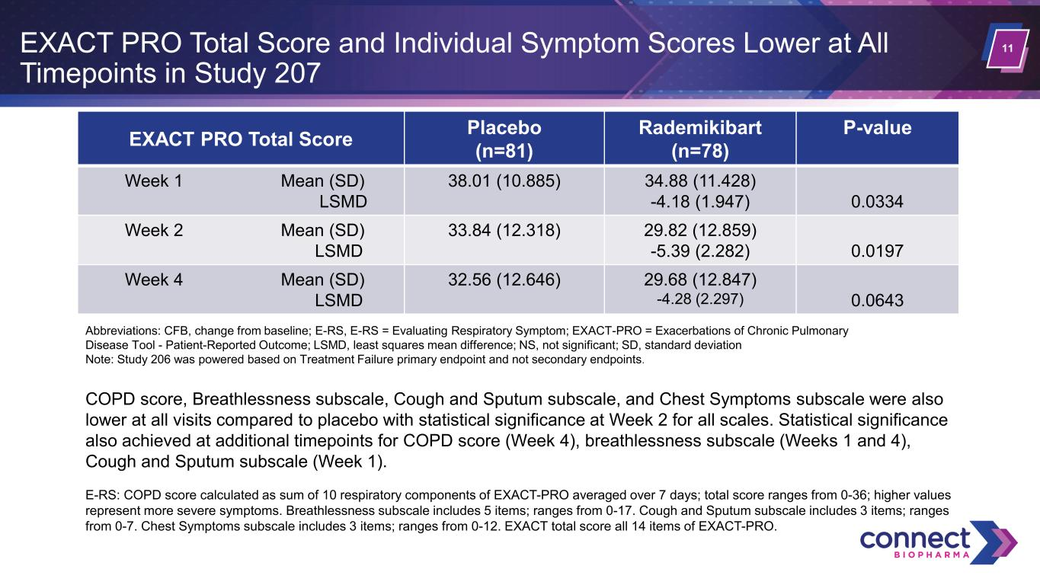
11EXACT PRO Total Score and Individual Symptom Scores Lower at All Timepoints in Study 207 EXACT PRO Total Score Placebo (n=81) Rademikibart (n=78) P-value Week 1 Mean (SD) LSMD 38.01 (10.885) 34.88 (11.428) -4.18 (1.947) 0.0334 Week 2 Mean (SD) LSMD 33.84 (12.318) 29.82 (12.859) -5.39 (2.282) 0.0197 Week 4 Mean (SD) LSMD 32.56 (12.646) 29.68 (12.847) -4.28 (2.297) 0.0643 COPD score, Breathlessness subscale, Cough and Sputum subscale, and Chest Symptoms subscale were also lower at all visits compared to placebo with statistical significance at Week 2 for all scales. Statistical significance also achieved at additional timepoints for COPD score (Week 4), breathlessness subscale (Weeks 1 and 4), Cough and Sputum subscale (Week 1). E-RS: COPD score calculated as sum of 10 respiratory components of EXACT-PRO averaged over 7 days; total score ranges from 0-36; higher values represent more severe symptoms. Breathlessness subscale includes 5 items; ranges from 0-17. Cough and Sputum subscale includes 3 items; ranges from 0-7. Chest Symptoms subscale includes 3 items; ranges from 0-12. EXACT total score all 14 items of EXACT-PRO. Abbreviations: CFB, change from baseline; E-RS, E-RS = Evaluating Respiratory Symptom; EXACT-PRO = Exacerbations of Chronic Pulmonary Disease Tool - Patient-Reported Outcome; LSMD, least squares mean difference; NS, not significant; SD, standard deviation Note: Study 206 was powered based on Treatment Failure primary endpoint and not secondary endpoints.

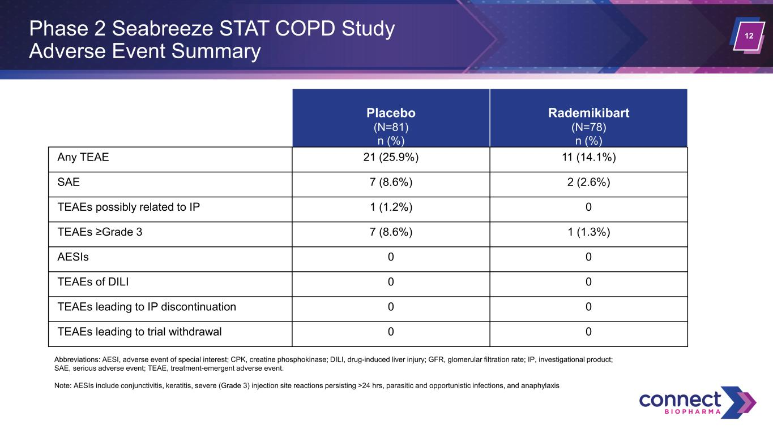
12 Placebo (N=81) n (%) Rademikibart (N=78) n (%) Any TEAE 21 (25.9%) 11 (14.1%) SAE 7 (8.6%) 2 (2.6%) TEAEs possibly related to IP 1 (1.2%) 0 TEAEs ≥Grade 3 7 (8.6%) 1 (1.3%) AESIs 0 0 TEAEs of DILI 0 0 TEAEs leading to IP discontinuation 0 0 TEAEs leading to trial withdrawal 0 0 Phase 2 Seabreeze STAT COPD Study Adverse Event Summary Abbreviations: AESI, adverse event of special interest; CPK, creatine phosphokinase; DILI, drug-induced liver injury; GFR, glomerular filtration rate; IP, investigational product; SAE, serious adverse event; TEAE, treatment-emergent adverse event. Note: AESIs include conjunctivitis, keratitis, severe (Grade 3) injection site reactions persisting >24 hrs, parasitic and opportunistic infections, and anaphylaxis

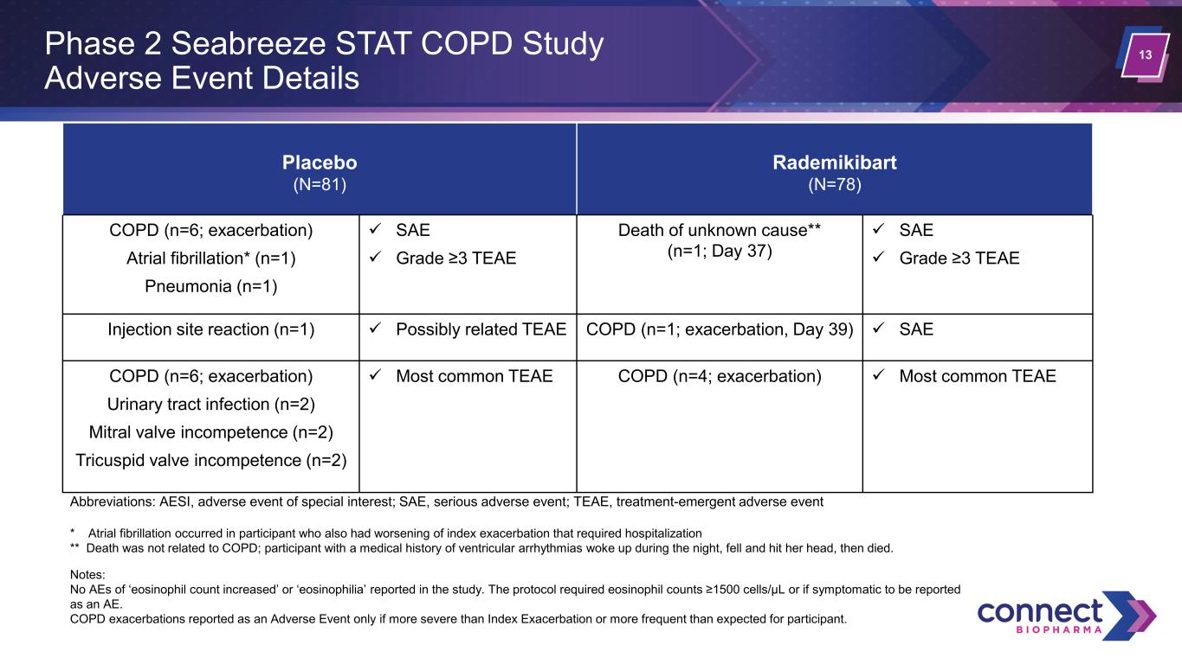
13 Placebo (N=81) Rademikibart (N=78) COPD (n=6; exacerbation) Atrial fibrillation* (n=1) Pneumonia (n=1) ✓ SAE ✓ Grade ≥3 TEAE Death of unknown cause** (n=1; Day 37) ✓ SAE ✓ Grade ≥3 TEAE Injection site reaction (n=1) ✓ Possibly related TEAE COPD (n=1; exacerbation, Day 39) ✓ SAE COPD (n=6; exacerbation) Urinary tract infection (n=2) Mitral valve incompetence (n=2) Tricuspid valve incompetence (n=2) ✓ Most common TEAE COPD (n=4; exacerbation) ✓ Most common TEAE Phase 2 Seabreeze STAT COPD Study Adverse Event Details Abbreviations: AESI, adverse event of special interest; SAE, serious adverse event; TEAE, treatment-emergent adverse event * Atrial fibrillation occurred in participant who also had worsening of index exacerbation that required hospitalization ** Death was not related to COPD; participant with a medical history of ventricular arrhythmias woke up during the night, fell and hit her head, then died. Notes: No AEs of ‘eosinophil count increased’ or ‘eosinophilia’ reported in the study. The protocol required eosinophil counts ≥1500 cells/μL or if symptomatic to be reported as an AE. COPD exacerbations reported as an Adverse Event only if more severe than Index Exacerbation or more frequent than expected for participant.

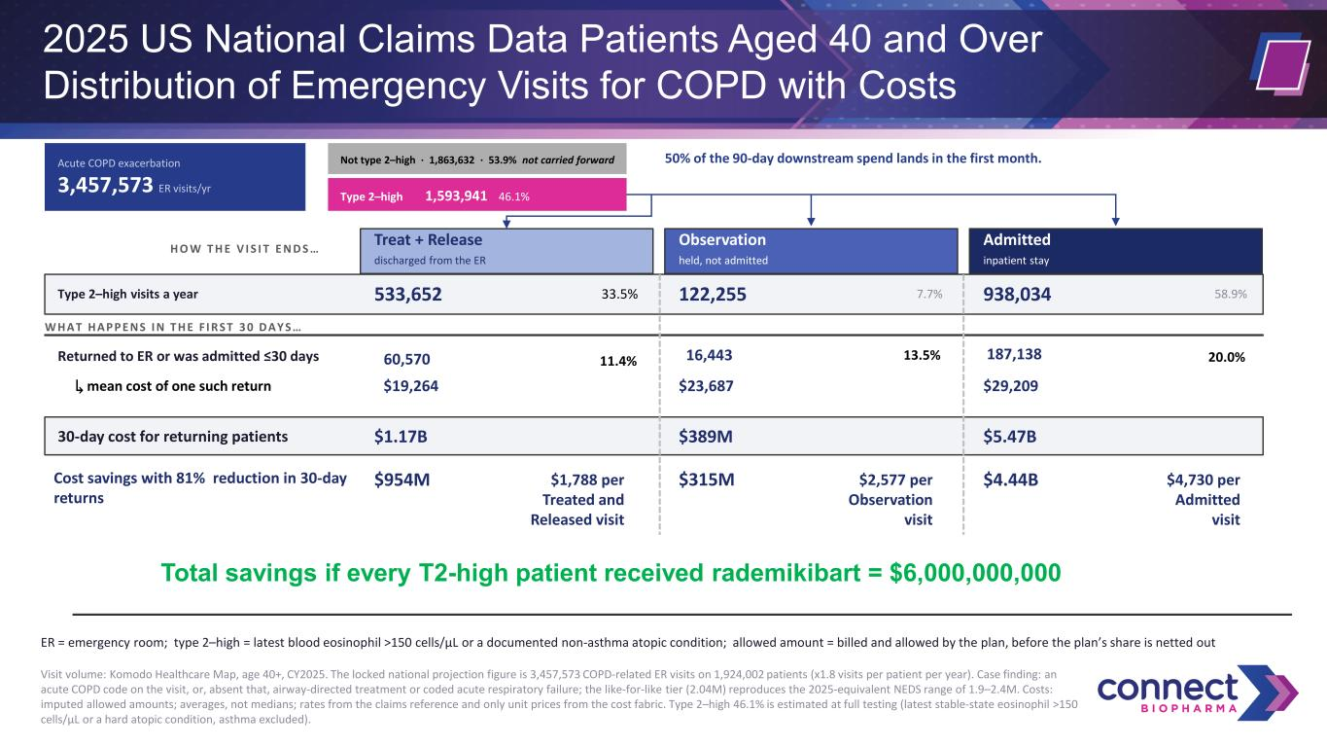
2025 US National Claims Data Patients Aged 40 and Over Distribution of Emergency Visits for COPD with Costs Acute COPD exacerbation 3,457,573 ER visits/yr Not type 2–high · 1,863,632 · 53.9% not carried forward Type 2–high 1,593,941 46.1% 50% of the 90-day downstream spend lands in the first month. H O W T H E V I S I T E N D S … Treat + Release discharged from the ER Observation held, not admitted Admitted inpatient stay Type 2–high visits a year 533,652 33.5% 122,255 7.7% 938,034 58.9% W H A T H A P P E N S I N T H E F I R S T 3 0 D A Y S … Returned to ER or was admitted ≤30 days 11.4%60,570 13.5%16,443 20.0%187,138 ↳ mean cost of one such return $19,264 $23,687 $29,209 30-day cost for returning patients $1.17B $389M $5.47B Cost savings with 81% reduction in 30-day returns $954M $1,788 per Treated and Released visit $315M $2,577 per Observation visit $4.44B $4,730 per Admitted visit ER = emergency room; type 2–high = latest blood eosinophil >150 cells/µL or a documented non-asthma atopic condition; allowed amount = billed and allowed by the plan, before the plan’s share is netted out Visit volume: Komodo Healthcare Map, age 40+, CY2025. The locked national projection figure is 3,457,573 COPD-related ER visits on 1,924,002 patients (x1.8 visits per patient per year). Case finding: an acute COPD code on the visit, or, absent that, airway-directed treatment or coded acute respiratory failure; the like-for-like tier (2.04M) reproduces the 2025-equivalent NEDS range of 1.9–2.4M. Costs: imputed allowed amounts; averages, not medians; rates from the claims reference and only unit prices from the cost fabric. Type 2–high 46.1% is estimated at full testing (latest stable-state eosinophil >150 cells/µL or a hard atopic condition, asthma excluded). Total savings if every T2-high patient received rademikibart = $6,000,000,000

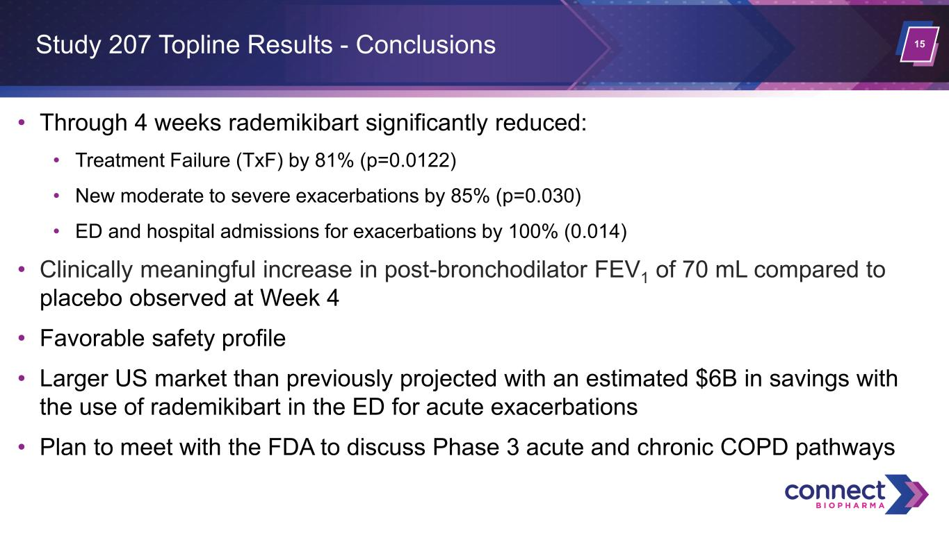
15 • Through 4 weeks rademikibart significantly reduced: • Treatment Failure (TxF) by 81% (p=0.0122) • New moderate to severe exacerbations by 85% (p=0.030) • ED and hospital admissions for exacerbations by 100% (0.014) • Clinically meaningful increase in post-bronchodilator FEV1 of 70 mL compared to placebo observed at Week 4 • Favorable safety profile • Larger US market than previously projected with an estimated $6B in savings with the use of rademikibart in the ED for acute exacerbations • Plan to meet with the FDA to discuss Phase 3 acute and chronic COPD pathways Study 207 Topline Results - Conclusions

